Management Control System

Software Training Materials

**Table of Contents**

1. INTRODUCTION OF MANAGEMENT CONTROL SYSTEM 5

How to Log in the MCS 5

2. FINANCE & ACCOUNTS WING 6

3. ACCOUNTS & BUDGET MANAGEMENT (SUB MODULE) 7

4.Accounts & Budget Management Menu Overview 9

4.1: Settings Menu Overview 10

4.1.1.1: Chart of Account Code (Settings) Add Account Code input field 10

4.1.1.2: Chart of Account Code (Settings) View of details 11

4.1.1.3: Chart of Account Code (Settings) Edit 11

4.1.1.4: Chart of Account Code (Settings) Delete 12

4.1.1.5: Chart of Account Code (Settings) Search 13

4.1.2.1: Chart of GoB Code (Settings) Add GoB Code input field 14

4.1.2.2: Chart of GoB Code (Settings) View of details 14

4.1.2.3: Chart of GoB Code (Settings) Edit Input Field 15

4.1.2.4: Chart of GoB Code (Settings) Delete 15

4.1.2.5: Chart of GoB Code (Settings) Search 16

4.1.3.1: Bank Account (Settings) Add Bank Account input field 17

4.1.3.2: Bank Account (Settings) View of details 18

4.1.3.3: Bank Account (Settings) Edit Input Field 18

4.1.3.4: Bank Account (Settings) Delete 19

4.1.3.5: Bank Account (Settings) Search 20

4.1.4.1: Office BBA HQ (Settings) Add Office input field 20

4.1.4.2: Office BBA HQ (Settings) View of details 21

4.1.4.3: Office BBA HQ (Settings) Edit Input Field 21

4.1.4.4: Office BBA HQ (Settings) Search 22

4.1.5.1: Supp/Cons/Contractor (Settings) Add Data (Supplier) Input Field 23

4.1.5.2: Supp/Cons/Contractor (Settings) View of details 24

4.1.5.3: Supp/Cons/Contractor (Settings) Add Supplier type Input Field 25

4.1.5.4: Supp/Cons/Contractor (Settings) View Details of Add Supplier type 25

4.1.5.4.1: Supp/Cons/Contractor (Settings) Add Supplier type Edit 26

4.1.5.4.2: Supp/Cons/Contractor (Settings) Add Supplier type Delete 26

4.1.5.5: Supp/Cons/Contractor (Settings) Edit Input Field 27

4.1.5.6: Supp/Cons/Contractor (Settings) Delete 27

4.1.5.7: Supp/Cons/Contractor (Settings) Search 28

4.1.6.1: Service (Settings) Add New Service 29

4.1.6.2: Service (Settings) View of details 29

4.1.6.3: Service (Settings) Edit Input Field 30

4.1.6.4: Service (Settings) Delete 31

4.1.6.5: Service (Settings) Search 31

4.2: Opening Balance Menu Overview 32

4.2.1: (Opening Balance) Add Opening Balance Input Field 32

4.2.2: (Opening Balance) View of Opening Balance 33

4.2.3: (Opening Balance) Edit 34

4.2.4: (Opening Balance) Delete 34

4.2.5: (Opening Balance) Search 35

4.2.6: (Opening Balance) Report 36

4.2.7: (Opening Balance) Print 38

4.3: Sub Opening Balance Menu Overview 39

39

4.3.1: (Sub Opening Balance) Add Opening Balance Input Field 39

4.3.2: (Opening Balance) View of Sub Opening Balance 40

4.3.3: (Sub Opening Balance) View of Single Details 40

4.3.3.1: (Sub Opening Balance) Single Details (Print) 41

4.3.3.2.1: (Sub Opening Balance) Single Details Edit (Sub Accounts For) 42

4.3.3.2.2: (Sub Opening Balance) Single Details Edit (Sub Accounts Info) 42

4.3.4: (Sub Opening Balance) Delete 43

4.3.5: (Sub Opening Balance) Search 44

4.3.6: (Sub Opening Balance) Report 45

4.3.7: (Sub Opening Balance) Print 46

4.4: Budgets Menu Overview 47

4.4.1.1: Entry (Budgets) Budget Entry input field 48

4.4.1.2: Entry (Budgets) View of Details 48

4.4.2.1: Manage (Budgets) View all budget info (Year Wage) 49

4.4.2.2: Manage (Budgets) View of single budget info 49

4.4.2.2.1: Manage (Budgets) View of single budget info (Edit) 50

4.4.2.2.2: Manage (Budgets) View of single budget info (Delete) 51

4.4.2.3: Manage (Budgets) Search 52

4.4.3.1: Expense Entry (Budgets) Expense Entry input field 52

4.4.3.2: Manage Expenses (Budgets) (incomplete ….) 52

4.4.4.1: Bill Entry (Budgets) (incomplete ….) 52

4.4.4.2: Manage Bill (Budgets) (incomplete ….) 52

4.4.5: Report (Budgets) (incomplete ….) 52

4.5: Voucher Menu Overview 53

4.5.1.1: Entry (Voucher) Voucher input form 53

4.5.1.2: Entry (Voucher) View of Voucher Entry Details 54

4.5.2.1: Manage (Voucher) View Details of Voucher Information 55

4.5.3.1: Report (Voucher) Report generator input field 55

4.5.4.1: Old Records (Voucher) Search old record input field & Search result(Old Voucher info) 56

# 1. INTRODUCTION OF MANAGEMENT CONTROL SYSTEM

……….

….

…….

…….

…….

Link for MCS is <http://192.168.3.7:3000/> which is accessible within BBA’s local network . After search will open a login page. Which is like –

### How to Log in the MCS

Figure 1: Log in Page

**Steps to Log in MCS**

1. User will input his Username
2. User will input his Password
3. Click Log In Button

If the username & password are correct, users will get access into the system.

# 2. FINANCE & ACCOUNTS WING

For Finance & Accounts module –

**Steps to Enter in Finance & Accounts**

1. After login will show this dashboard of MCS.

2. Click on the Finance & Accounts.

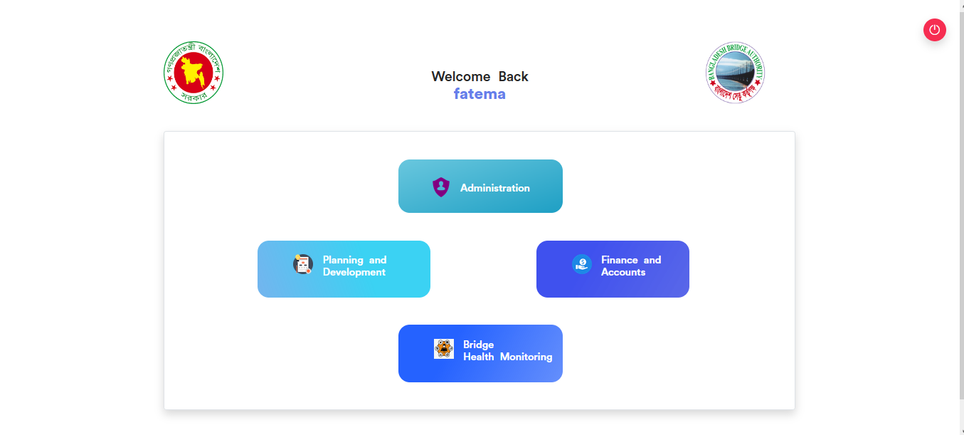

Figure 2.1: Dashboard of MCS

After entering into Finance & Accounts then there will show another dashboard with another four (4) Submodules. Such as-

1.Accounts & Budget Management

2.MIS Payroll Management

3.FDR Management

4.CPF Management

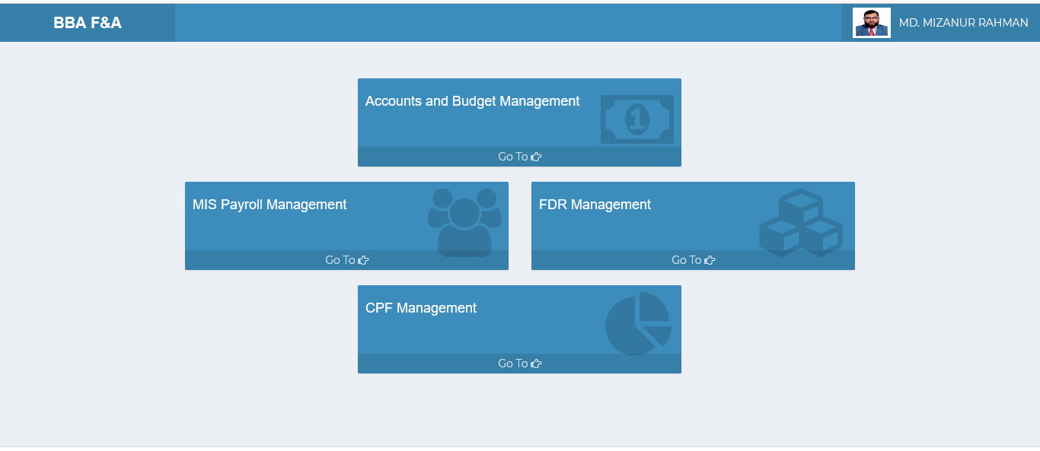

Figure 2.2: Dashboard of Finance & accounts Module.

**Overview of Finance & Accounts Sub Modules**

# 3. ACCOUNTS & BUDGET MANAGEMENT (SUB MODULE)

After clicking into Accounts and budget Management, it will redirect to the (Accounts & Budget Sub Module) dashboard with some menus.

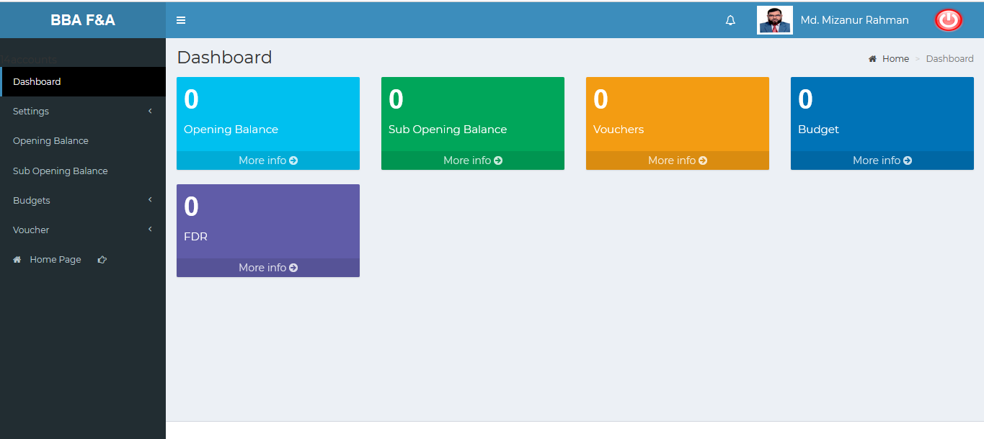

Figure 3: Dashboard of accounts & budget (sub module).

There are five segments on the right side of the Accounts & Budget Management Dashboard Such as **Opening Balance** ,**Sub Opening balance** ,**Vouchers, Budget** and **FDR.**

To get the details info about (**Opening Balance, Sub Opening Balance, Vouchers, Budget,FDR**) just click on the More info link after that it will redirect to relevant details info page.

# 4.ACCOUNTS & BUDGET MANAGEMENT MENU OVERVIEW

**Accounts & Budget Management Menu Overview**

## 4.1: Settings Menu Overview

**Overview of Settings**

Click on the settings menu after that there will appear six(06) sub-menu & they are **Chart of Account Code**, **Chart of GoB code, Bank Account** ,**Office (BBA HQ)** ,**Supp/Cons/Contractor** ,**Service**

### 4.1.1.1: Chart of Account Code (Settings) Add Account Code input field

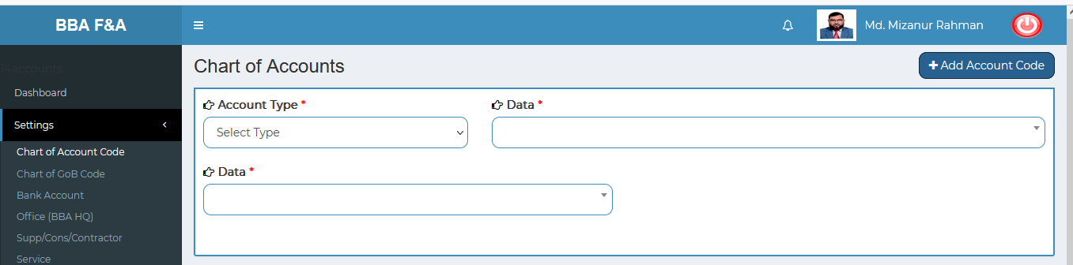

Figure 4.1.1.1: chart of account code(settings)add account code input field

### 4.1.1.2: Chart of Account Code (Settings) View of details

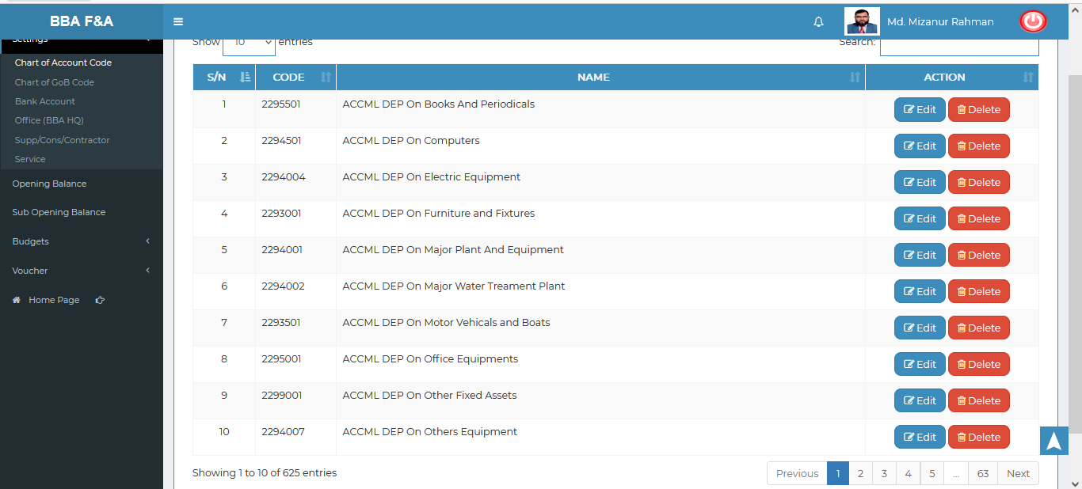

Figure 4.1.1.2: chart of account code(settings)View of details

### 4.1.1.3: Chart of Account Code (Settings) Edit

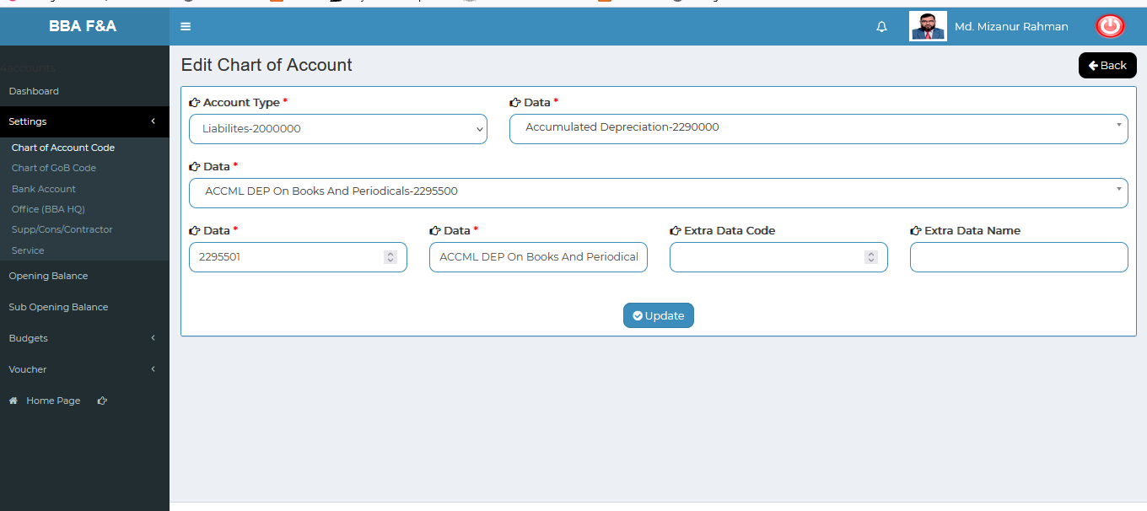

Figure 4.1.1.3: chart of account code(settings)View of details

### 4.1.1.4: Chart of Account Code (Settings) Delete

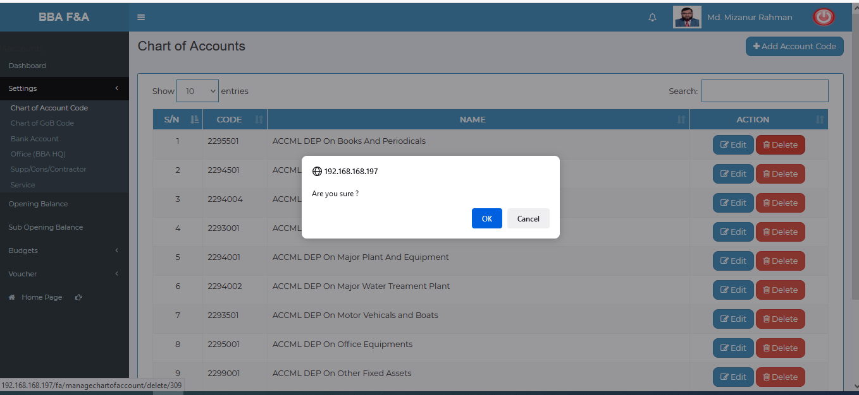

Figure 4.1.1.4: chart of account code(settings)delete

### 4.1.1.5: Chart of Account Code (Settings) Search

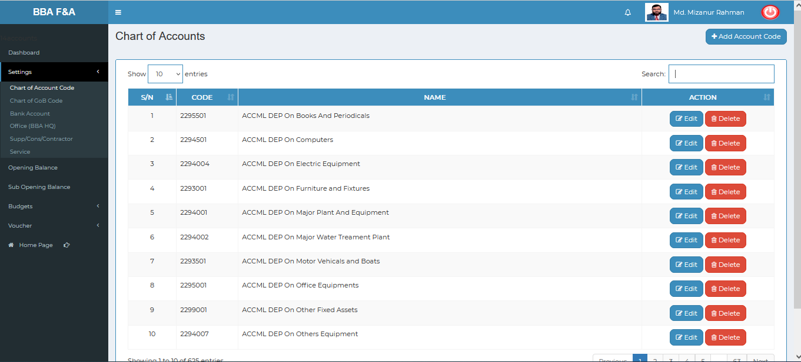

Figure 4.1.1.5: chart of account code(settings)before search

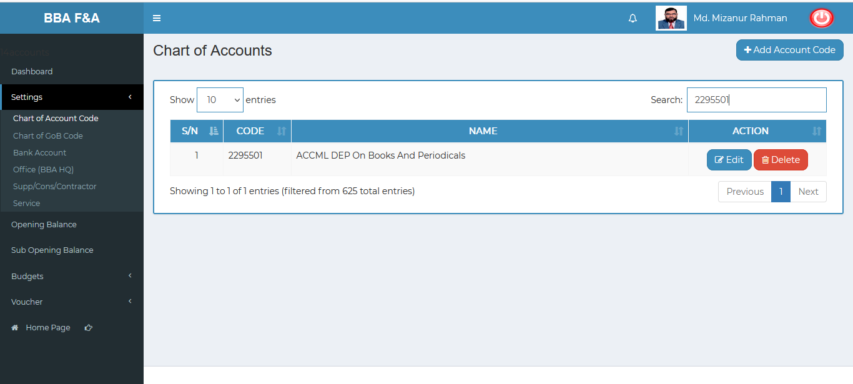 Figure 4.1.1.5: chart of account code(settings)after search

### 4.1.2.1: Chart of GoB Code (Settings) Add GoB Code input field

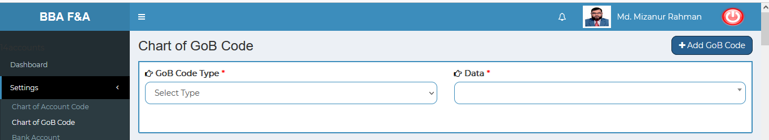

Figure 4.1.2.1: chart of gob code(settings)add gob code input field

### 4.1.2.2: Chart of GoB Code (Settings) View of details

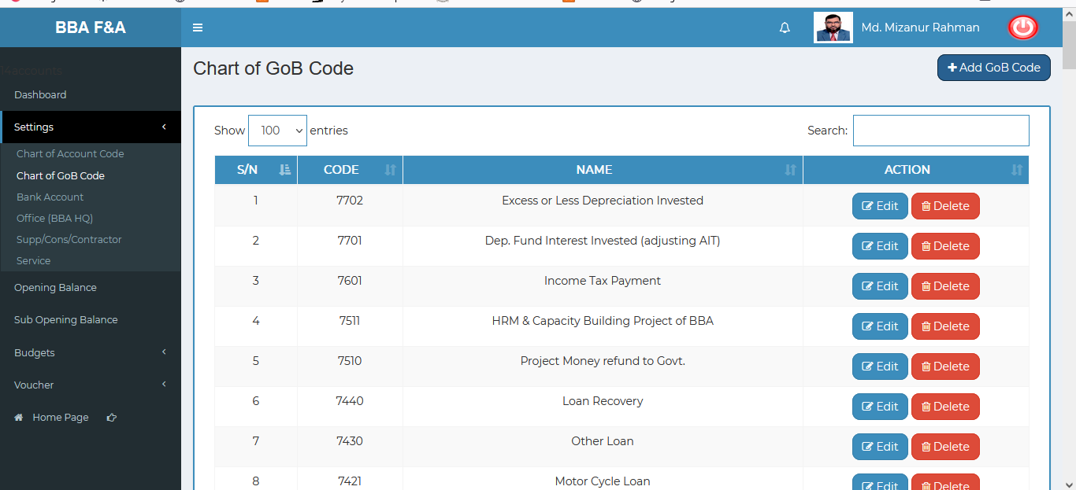

Figure 4.1.2.2: chart of Gob code(settings)View of details

### 4.1.2.3: Chart of GoB Code (Settings) Edit Input Field

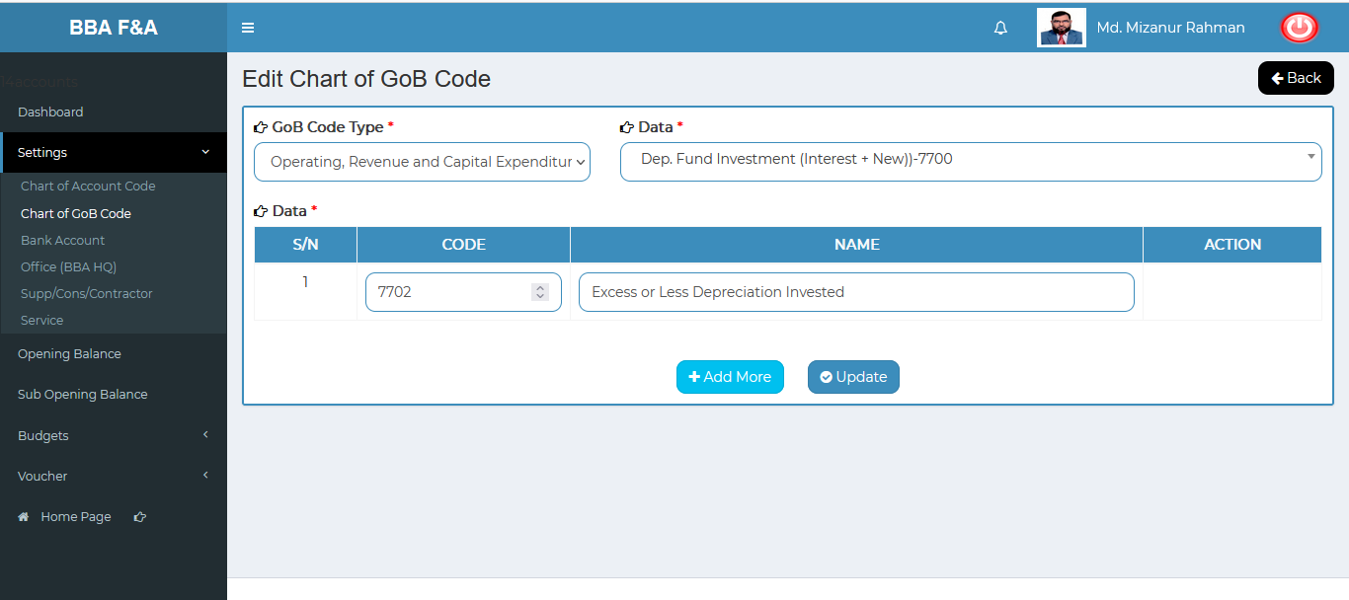

Figure 4.1.2.3: chart of GoB code (settings) Update input field

### 4.1.2.4: Chart of GoB Code (Settings) Delete

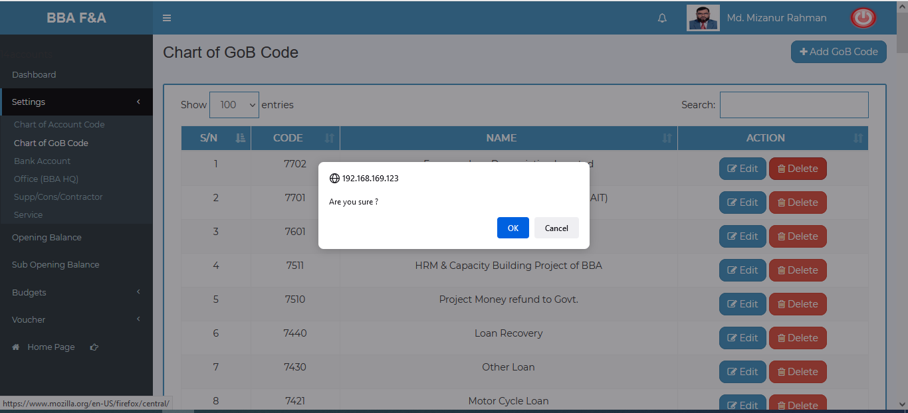

Figure 4.1.2.4: chart of GoB code(settings)delete

### 4.1.2.5: Chart of GoB Code (Settings) Search

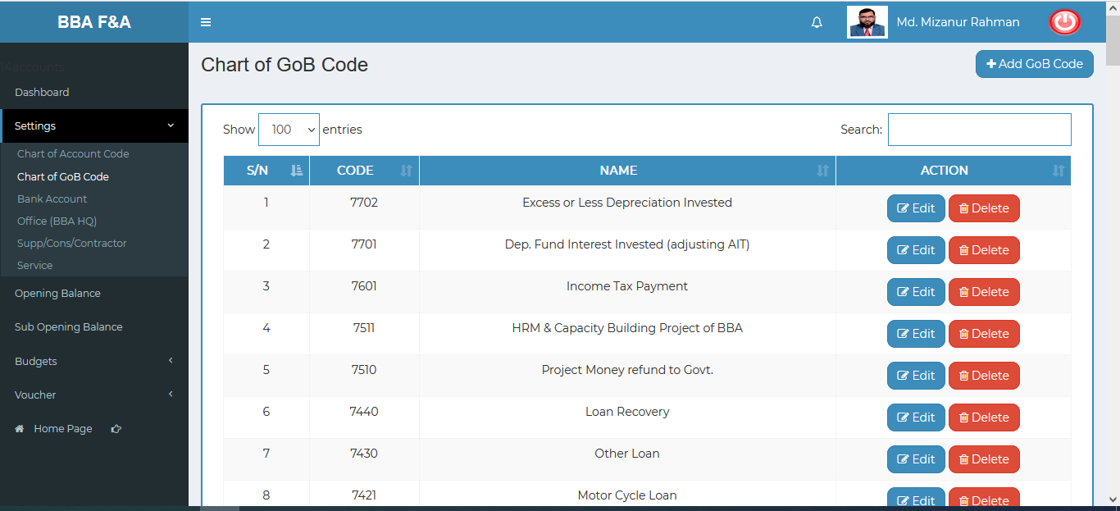

Figure 4.1.2.5: chart of GoB code(settings)before search

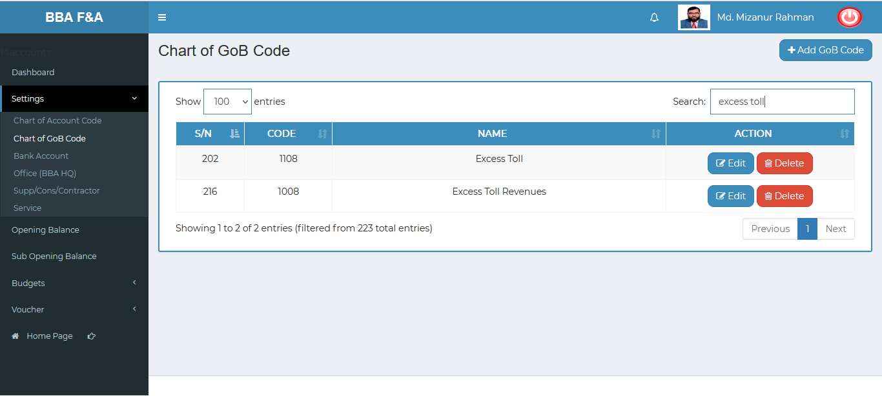

Figure 4.1.2.5: chart of GoB code(settings)after search

### 4.1.3.1: Bank Account (Settings) Add Bank Account input field

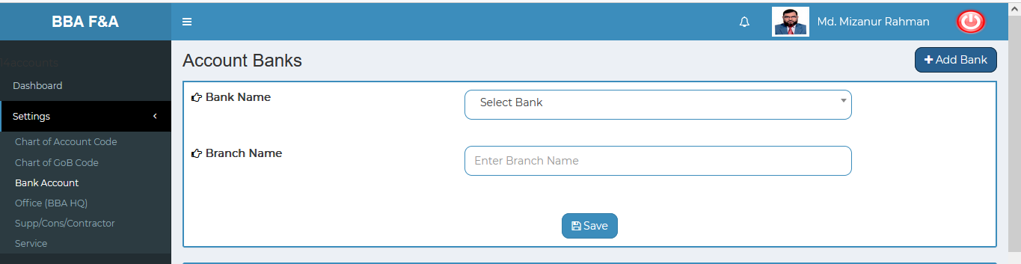

Figure 4.1.3.1: Bank account (settings)add bank account input field

### 4.1.3.2: Bank Account (Settings) View of details

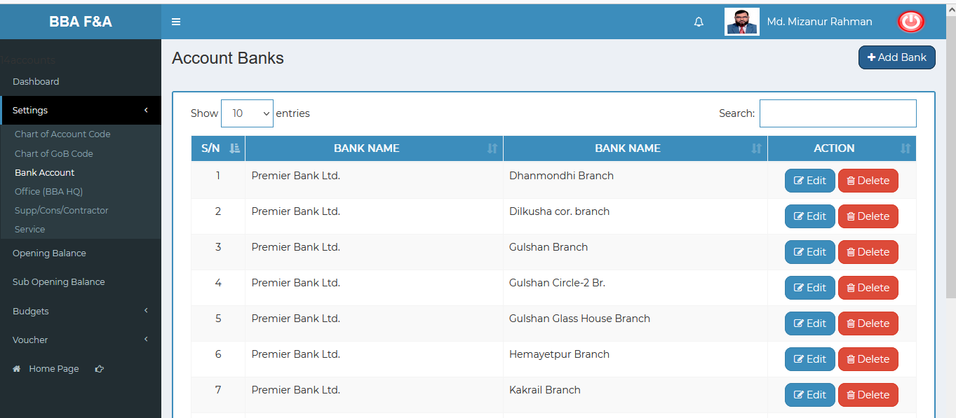

Figure 4.1.3.2: Bank Account (settings) View of details

### 4.1.3.3: Bank Account (Settings) Edit Input Field

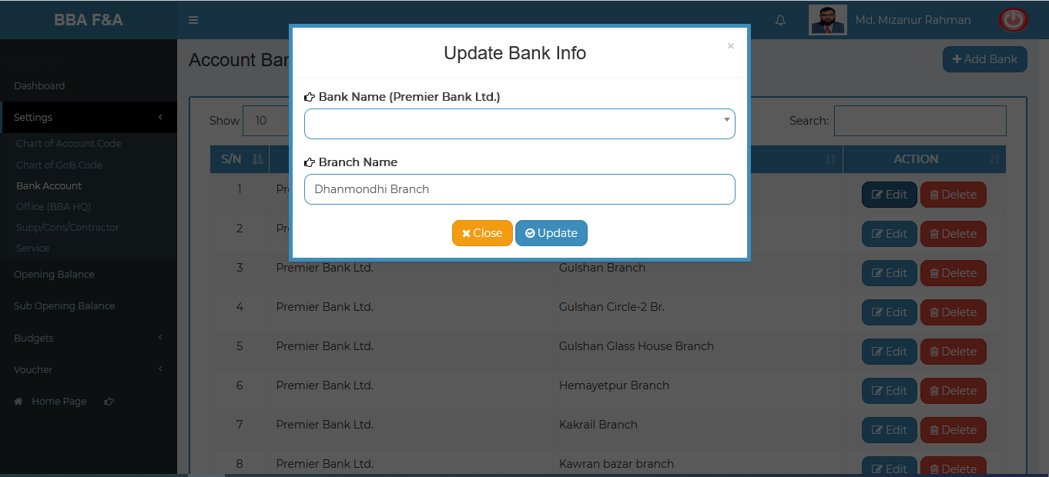

Figure 4.1.3.3: Bank Account (settings) Update input field

### 4.1.3.4: Bank Account (Settings) Delete

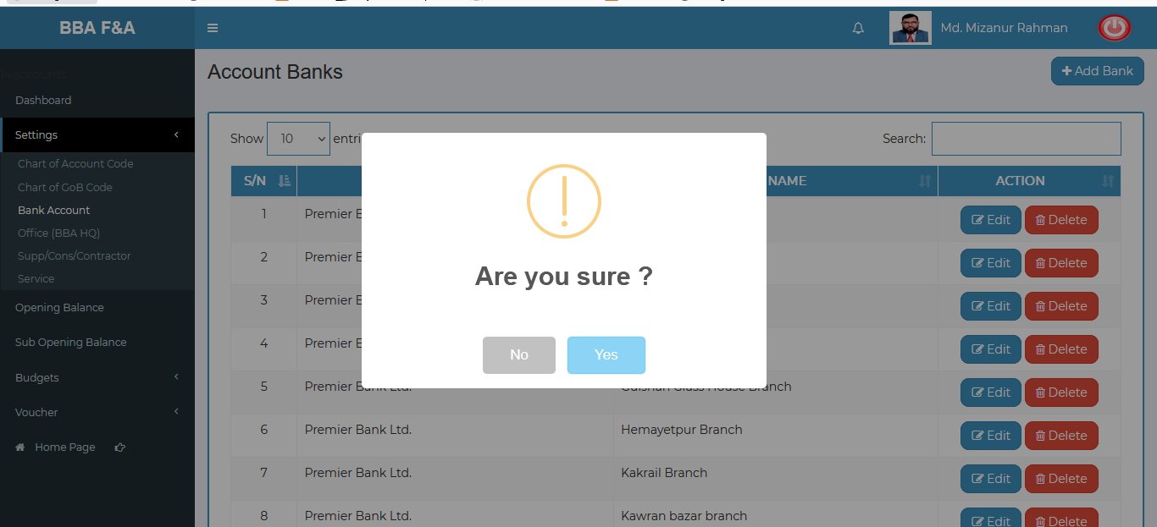

Figure 4.1.3.4: bank account (settings) delete

### 4.1.3.5: Bank Account (Settings) Search

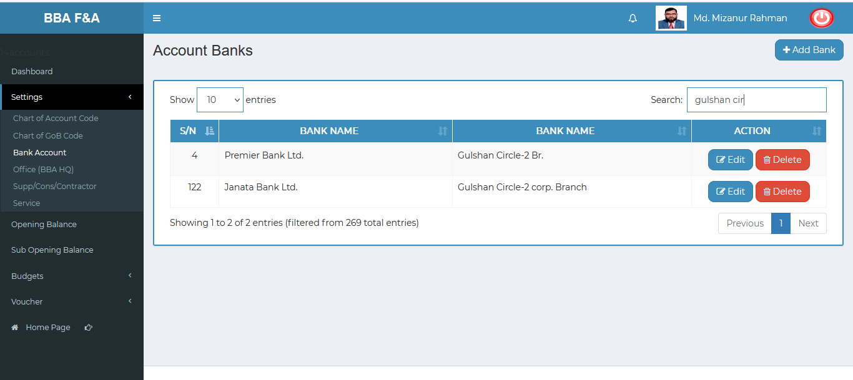

Figure 4.1.3.5: Bank account (settings) search

### 4.1.4.1: Office BBA HQ (Settings) Add Office input field

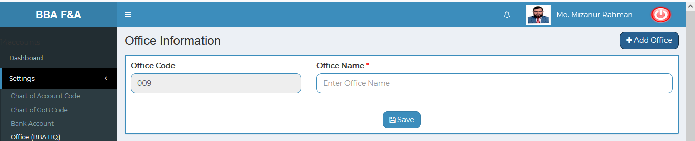

Figure 4.1.4.1: office bba hq (settings)add office input field

### 4.1.4.2: Office BBA HQ (Settings) View of details

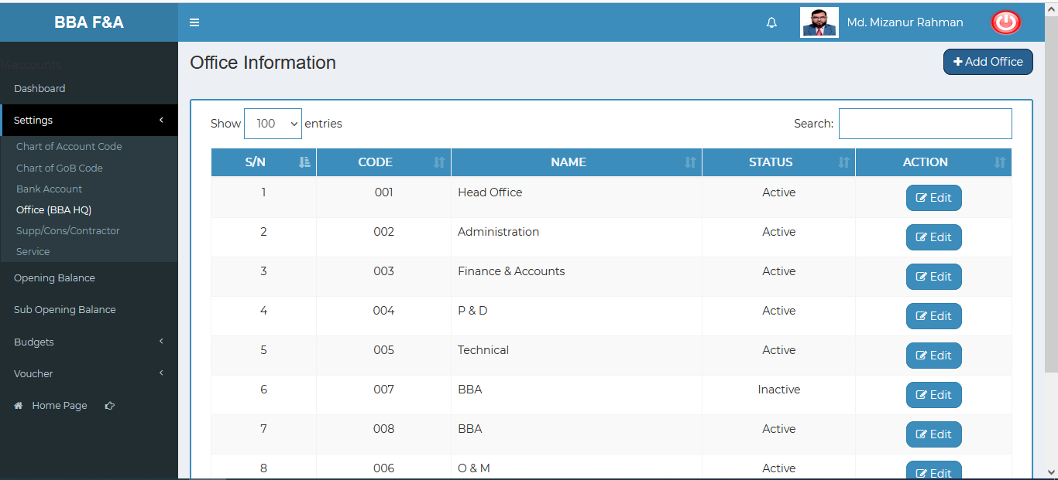

Figure 4.1.4.2: office bba hq (settings) View of details

### 4.1.4.3: Office BBA HQ (Settings) Edit Input Field

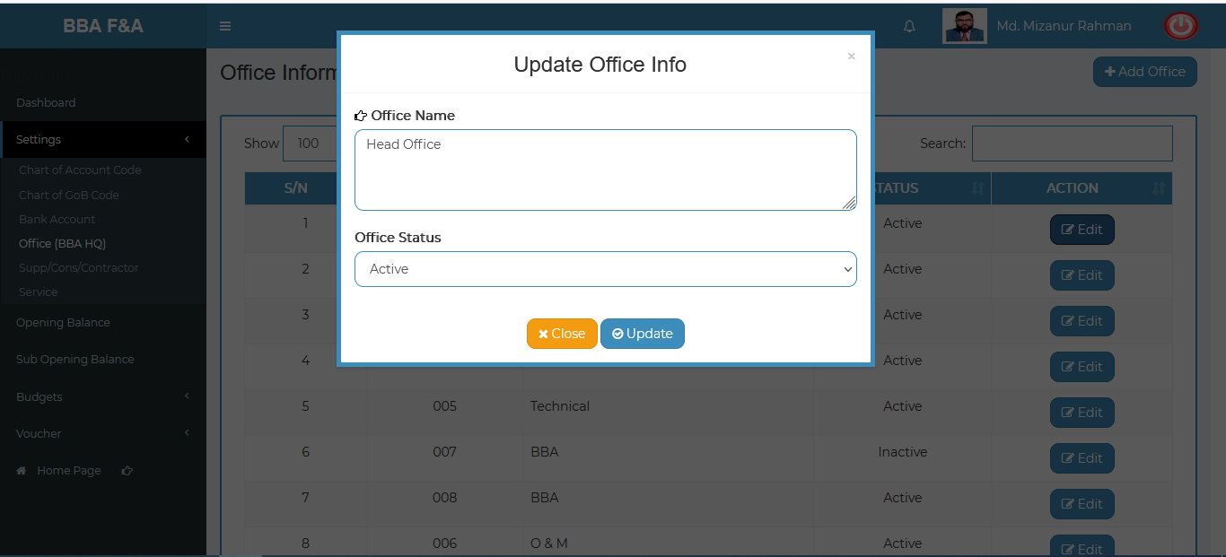

Figure 4.1.4.3: office bba hq (settings) Update input field

### 4.1.4.4: Office BBA HQ (Settings) Search

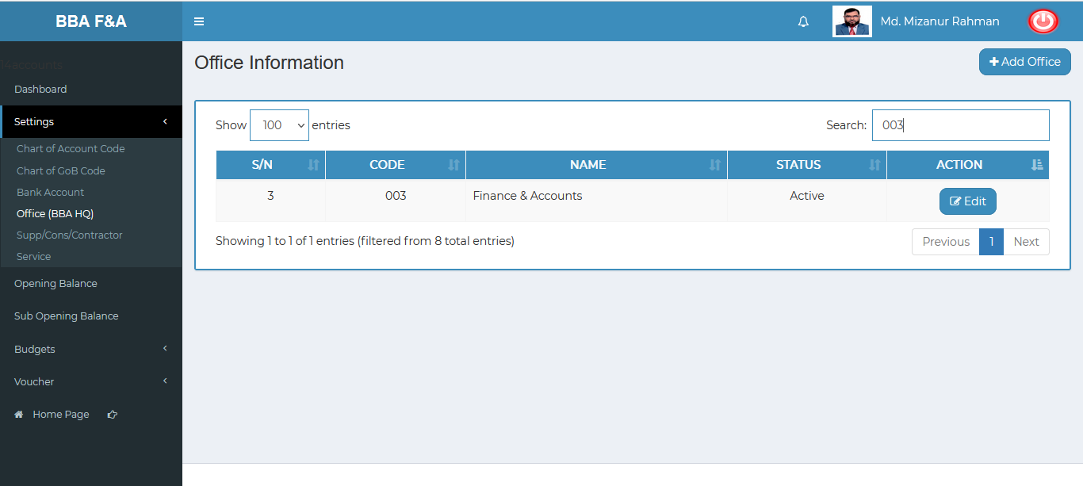

Figure 4.1.4.4: Office bba hq (settings) search

### 4.1.5.1: Supp/Cons/Contractor (Settings) Add Data (Supplier) Input Field

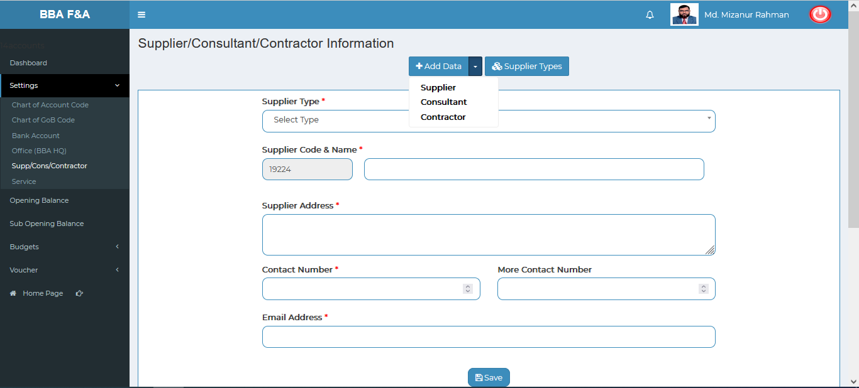

Figure 4.1.5.1.1: Supp/cons/contractor (settings)add data(supplier) input field

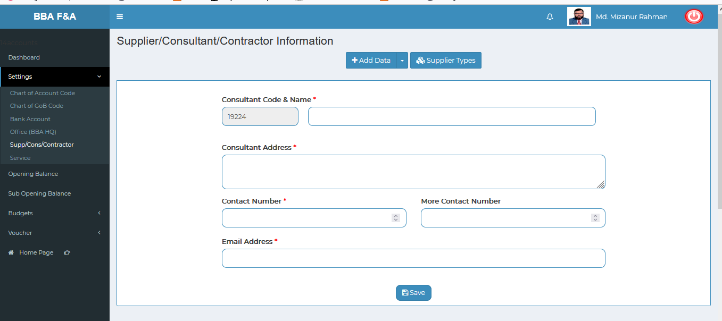

Figure 4.1.5.1.2: Supp/cons/contractor (settings)add data (consultant) input field

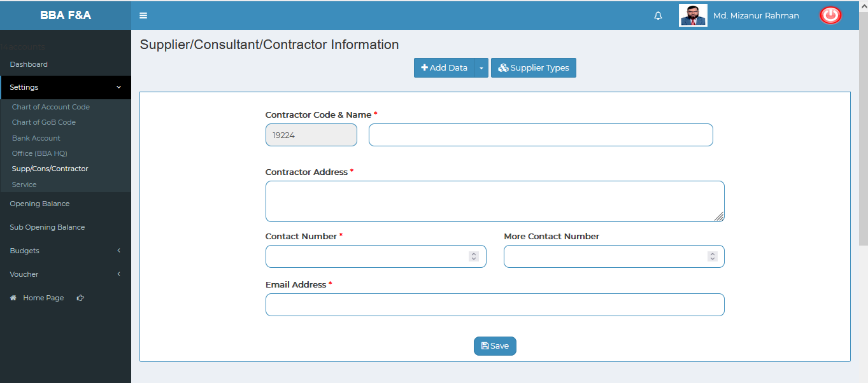

Figure 4.1.5.1.3: Supp/cons/contractor (settings)add data (contractor) input field

### 4.1.5.2: Supp/Cons/Contractor (Settings) View of details

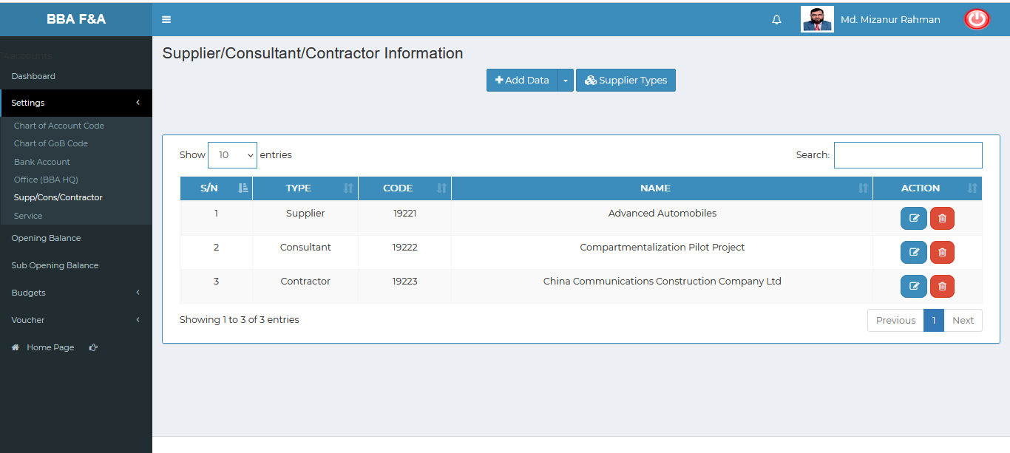

Figure 4.1.5.2: Supp/Cons/Contractor (settings) View of details

### 4.1.5.3: Supp/Cons/Contractor (Settings) Add Supplier type Input Field

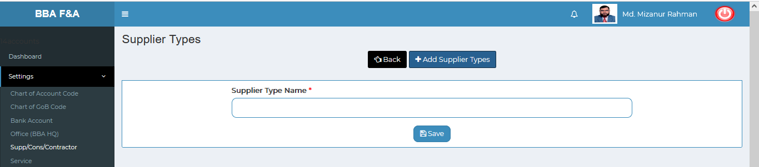

Figure 4.1.5.3: Supp/Cons/Contractor (settings) Add supplier type input field

### 4.1.5.4: Supp/Cons/Contractor (Settings) View Details of Add Supplier type

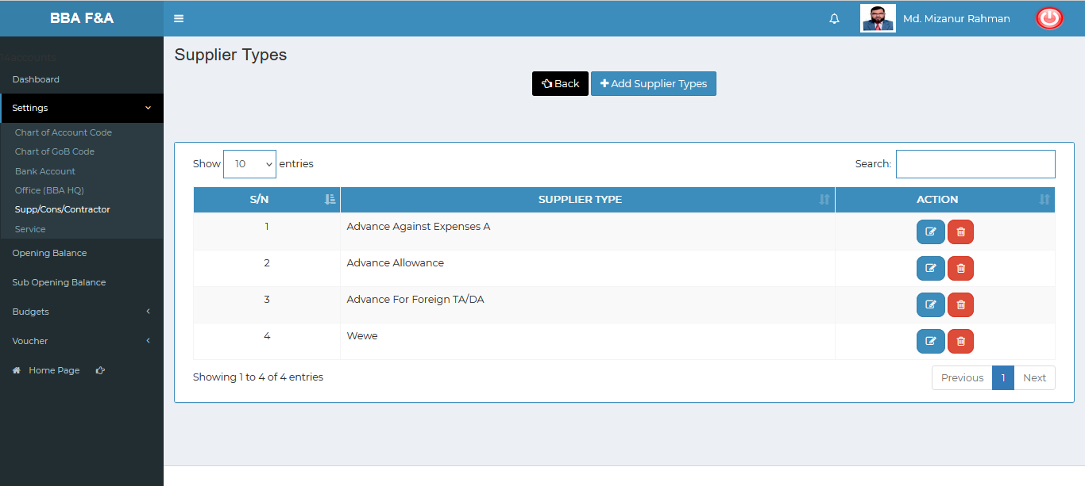 Figure 4.1.5.4: Supp/Cons/Contractor (settings) view details of add supplier type

### 4.1.5.4.1: Supp/Cons/Contractor (Settings) Add Supplier type Edit

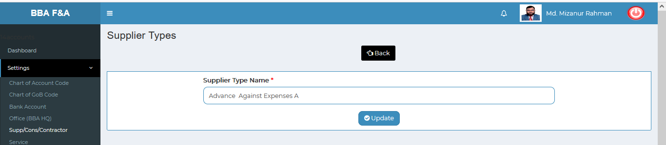

Figure 4.1.5.4.1: Supp/Cons/Contractor (settings) Add supplier type edit

### 4.1.5.4.2: Supp/Cons/Contractor (Settings) Add Supplier type Delete

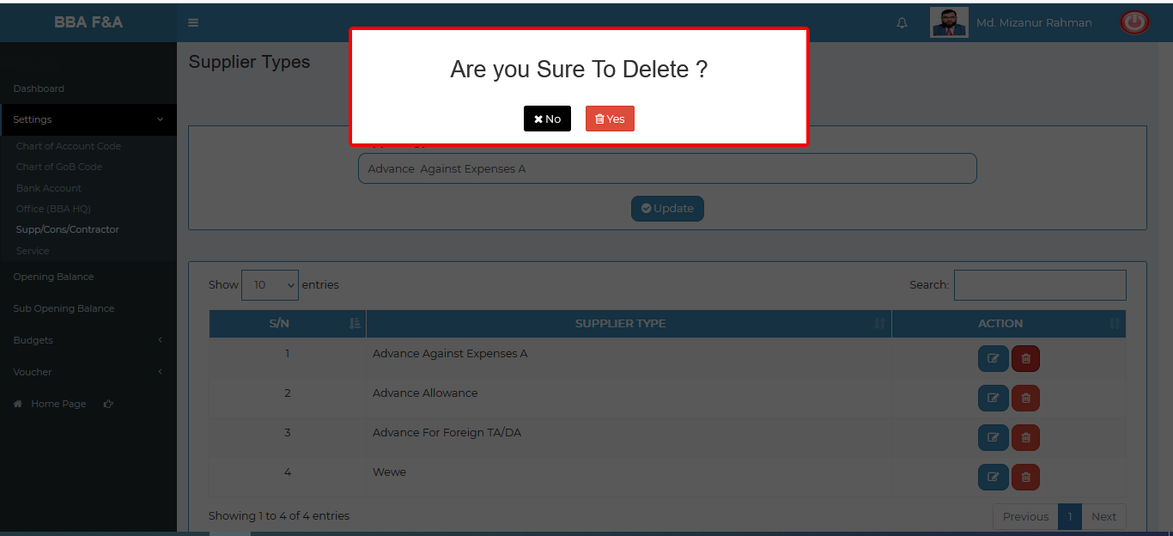

Figure 4.1.5.4.2: Supp/Cons/Contractor (settings) Add supplier type delete

### 4.1.5.5: Supp/Cons/Contractor (Settings) Edit Input Field

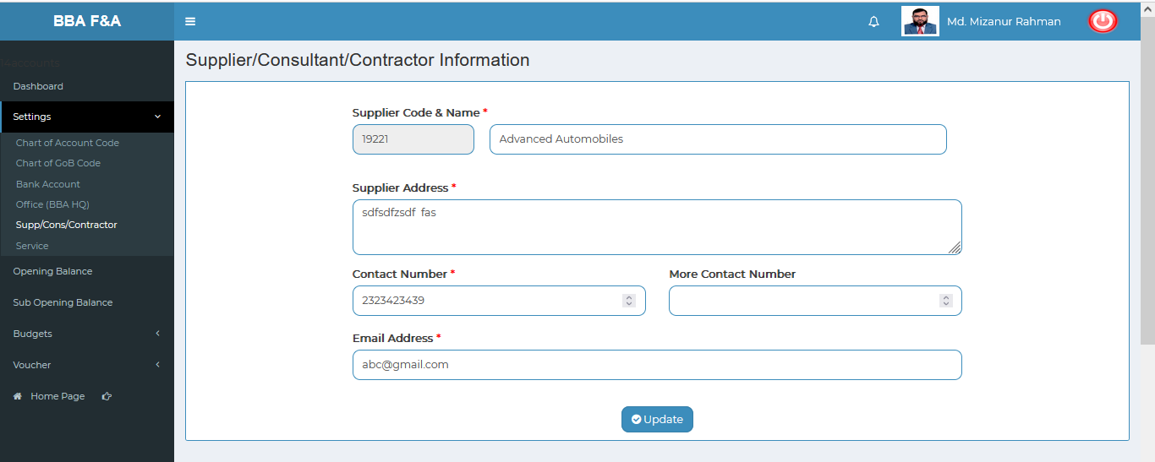

Figure 4.1.5.5: Supp/cons/contractor (settings) Update input field

### 4.1.5.6: Supp/Cons/Contractor (Settings) Delete

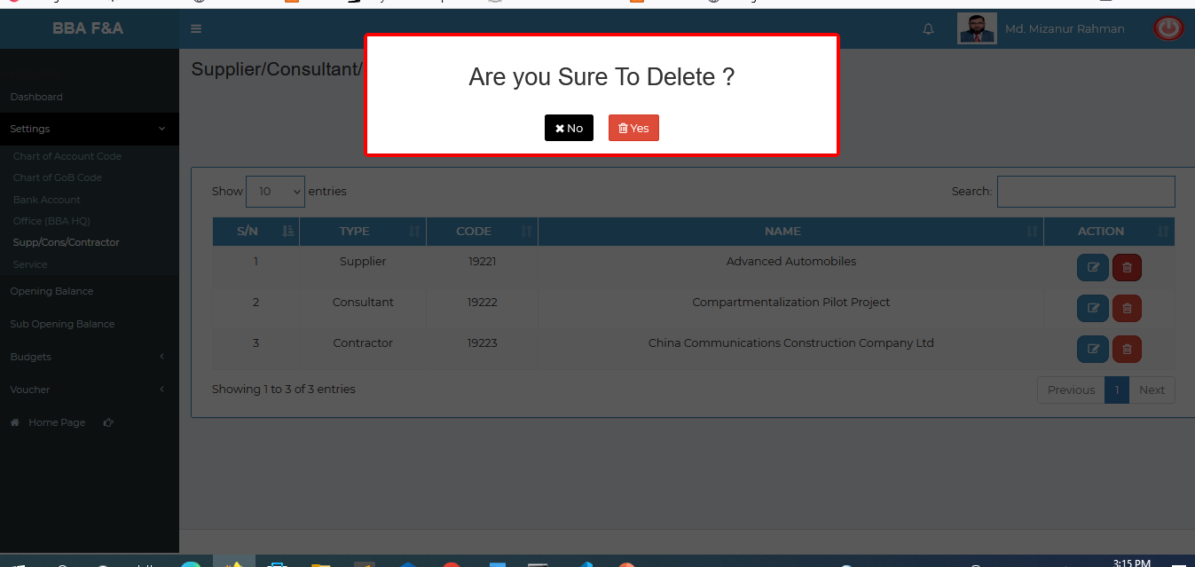

Figure 4.1.5.6: Supp/Cons/Contractor (settings) Delete

### 4.1.5.7: Supp/Cons/Contractor (Settings) Search

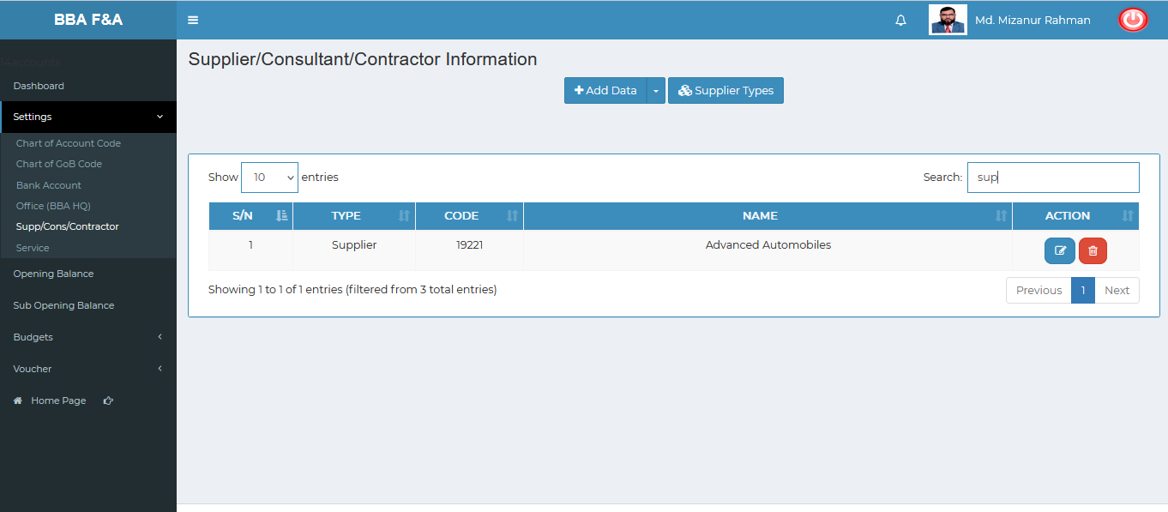

Figure 4.1.5.7: Supp/Cons/Contractor (settings) search

### 4.1.6.1: Service (Settings) Add New Service

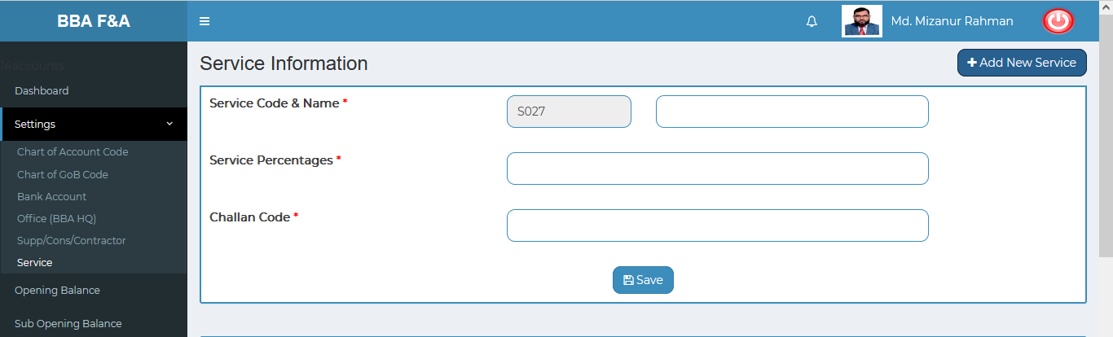

Figure 4.1.6.1: Service (settings)add new service input field

### 4.1.6.2: Service (Settings) View of details

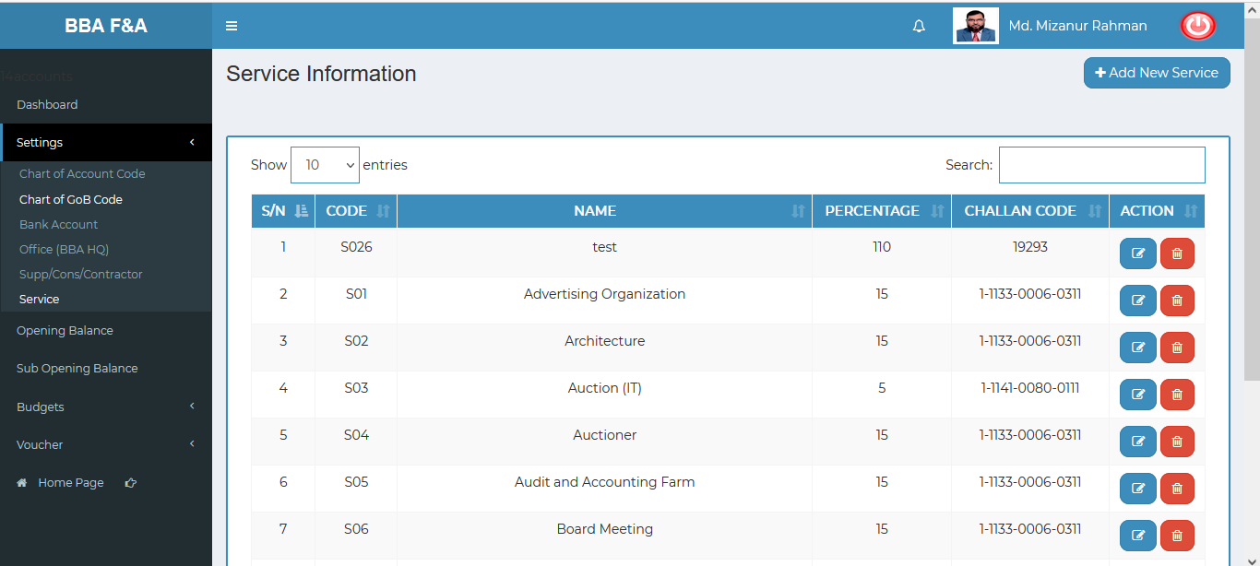

Figure 4.1.6.2: Service (settings) View of details

### 4.1.6.3: Service (Settings) Edit Input Field

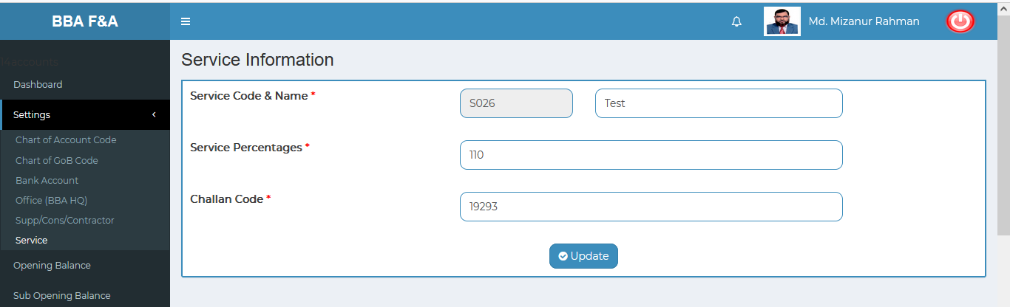

Figure 4.1.6.3: Service (settings) Update input field

### 4.1.6.4: Service (Settings) Delete

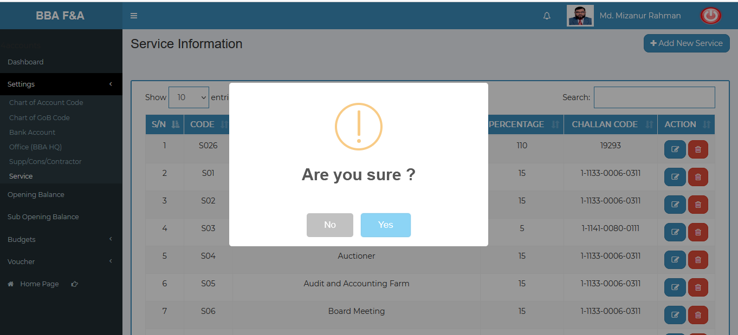

Figure 4.1.6.4: Service (settings) delete

### 4.1.6.5: Service (Settings) Search

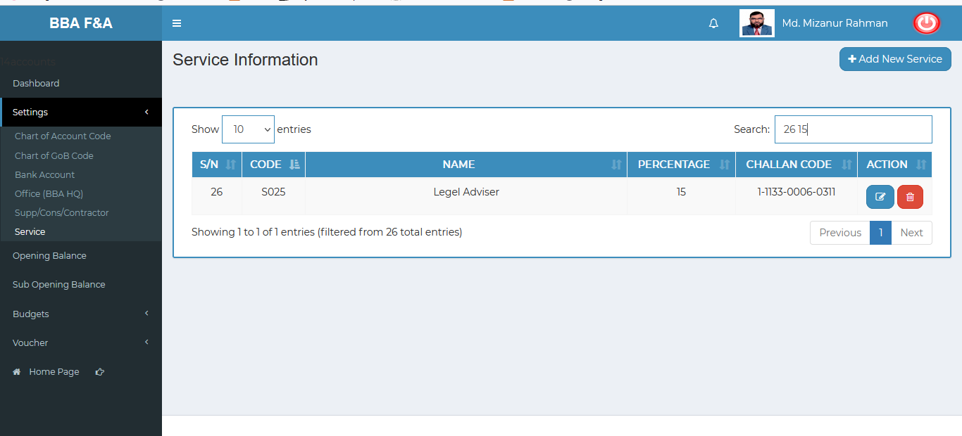

Figure 4.1.6.5: service (settings) search

## 4.2: Opening Balance Menu Overview

### 4.2.1: (Opening Balance) Add Opening Balance Input Field

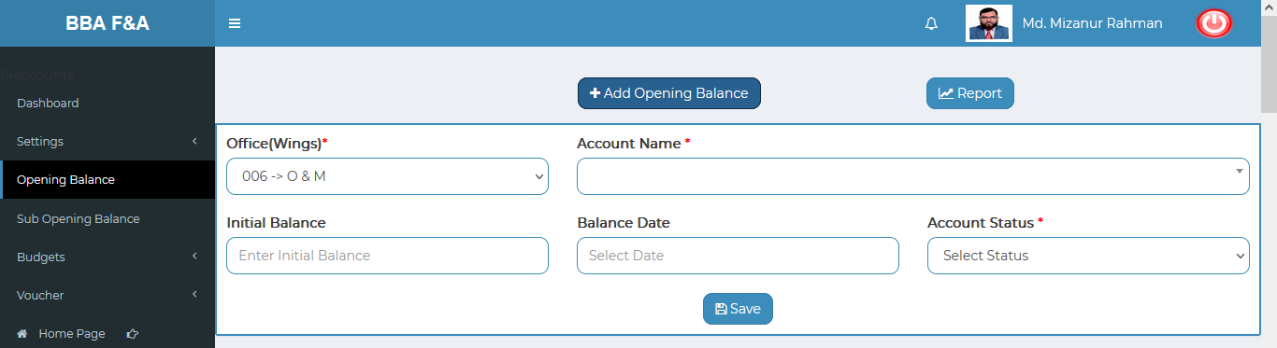

Figure 4.2.1: (Opening balance) add opening balance input field

### 4.2.2: (Opening Balance) View of Opening Balance

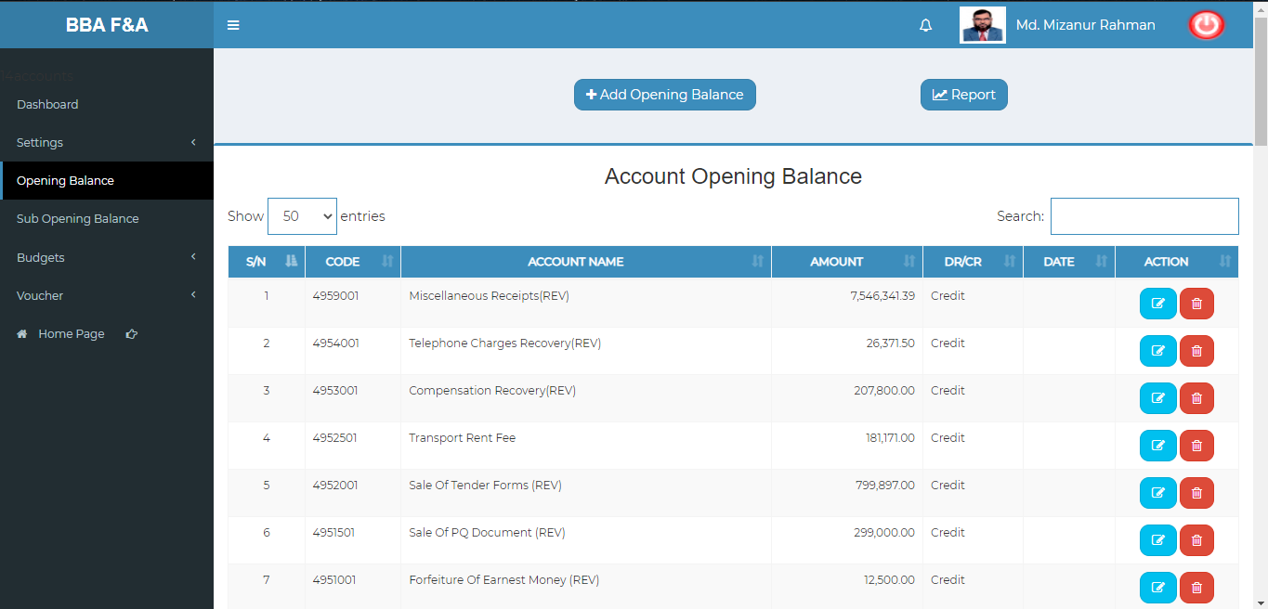

Figure 4.2.2: (Opening balance) View of opening balance

### 4.2.3: (Opening Balance) Edit

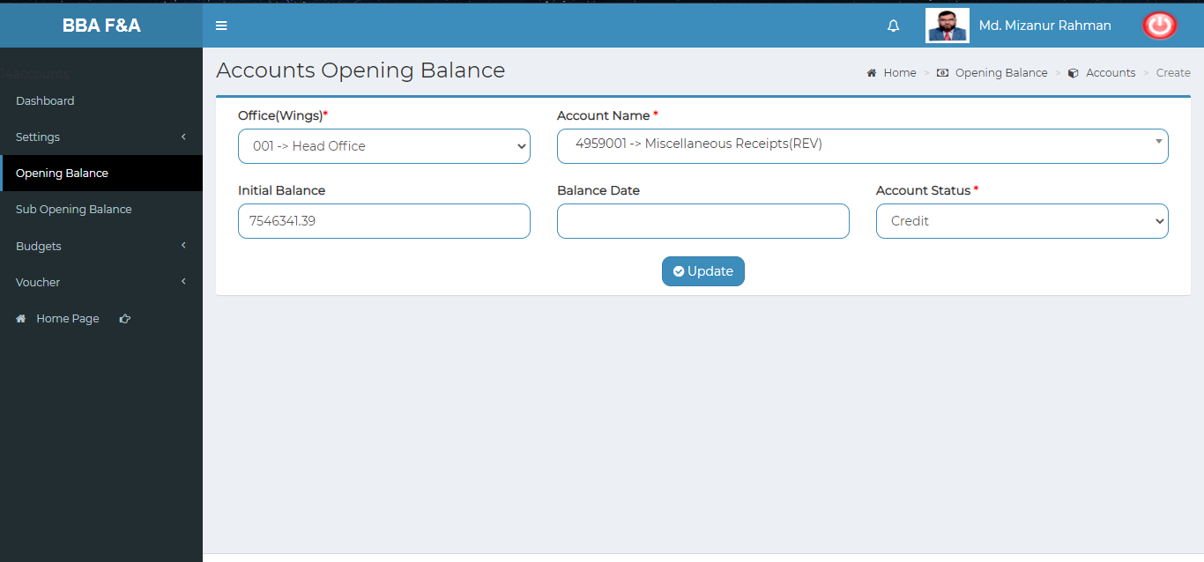

Figure 4.2.3: (Opening balance) edit

### 4.2.4: (Opening Balance) Delete

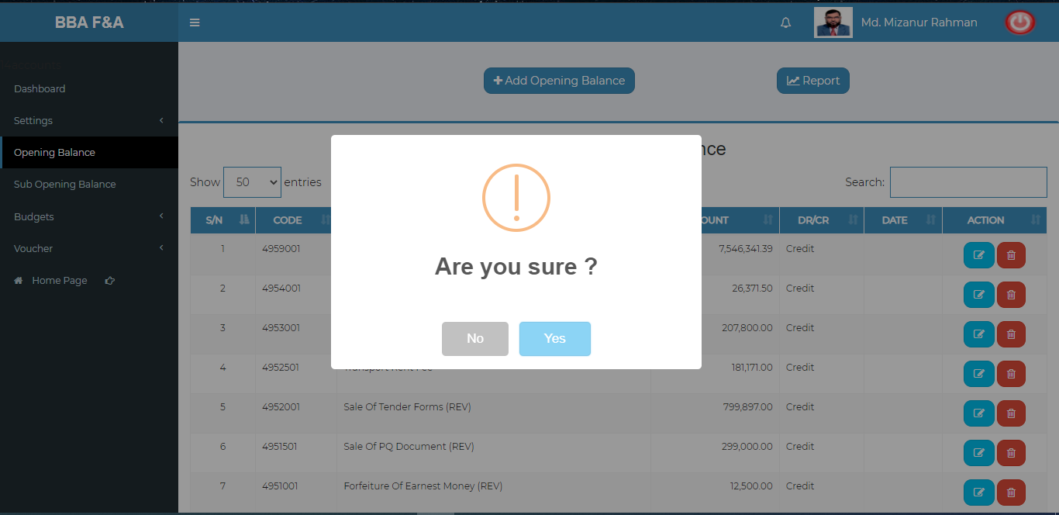

Figure 4.2.4: (Opening balance) Delete

### 4.2.5: (Opening Balance) Search

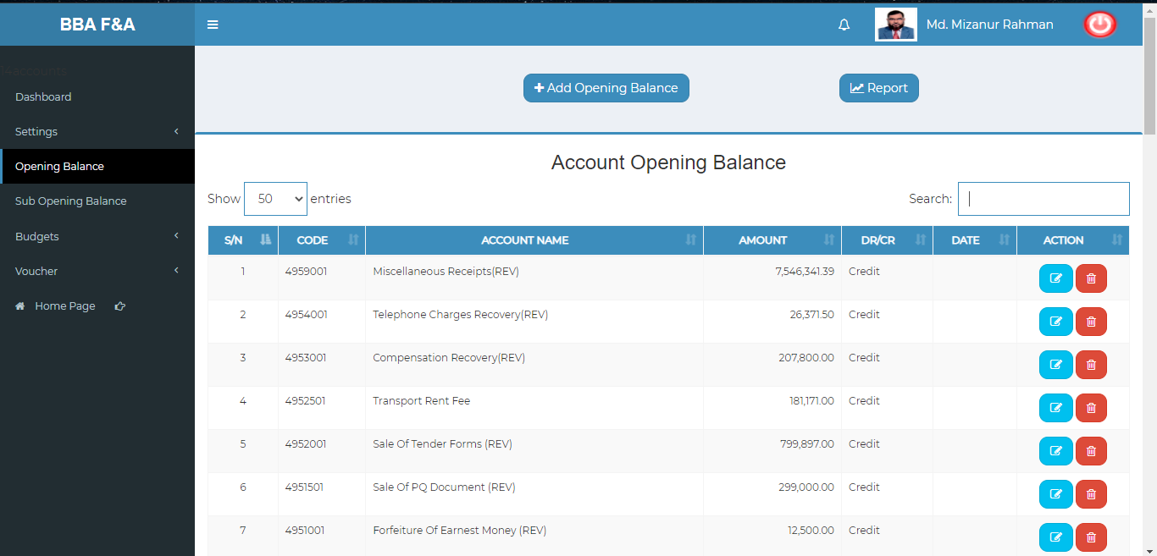

Figure 4.2.5: (Opening balance) before the search

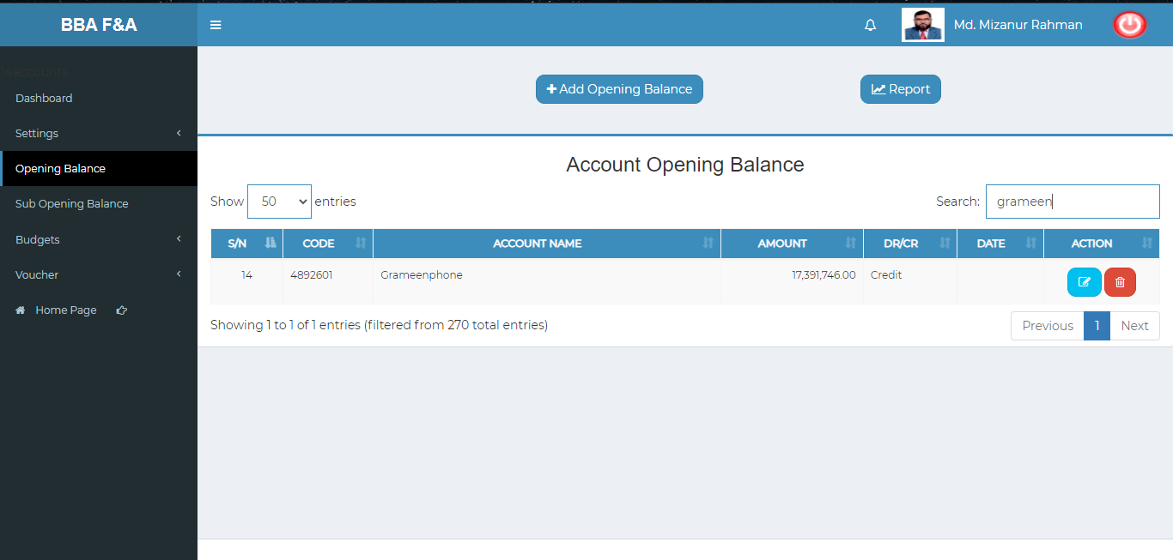

Figure 4.2.5.1: (Opening balance) After a search

### 4.2.6: (Opening Balance) Report

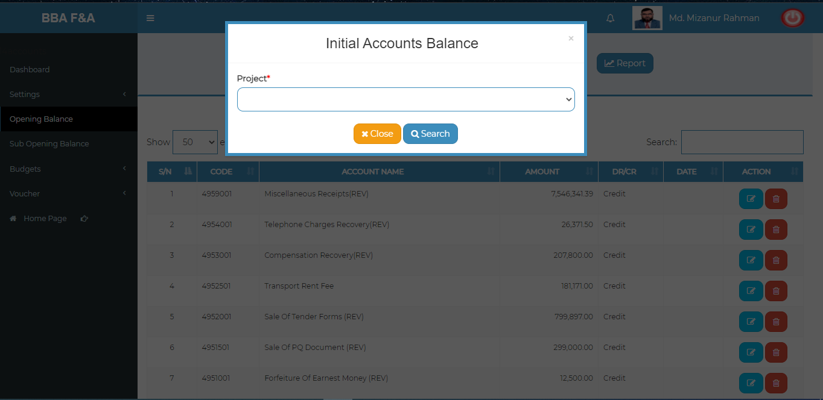

Figure 4.2.6: (Opening balance) Report (pop-up modal)

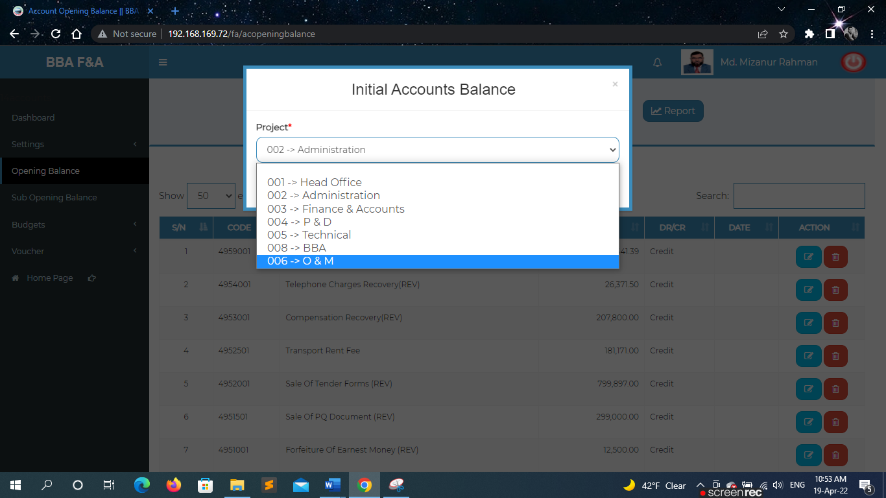

Figure 4.2.6.1: (Opening balance) Report (choose option from pop-up modal)

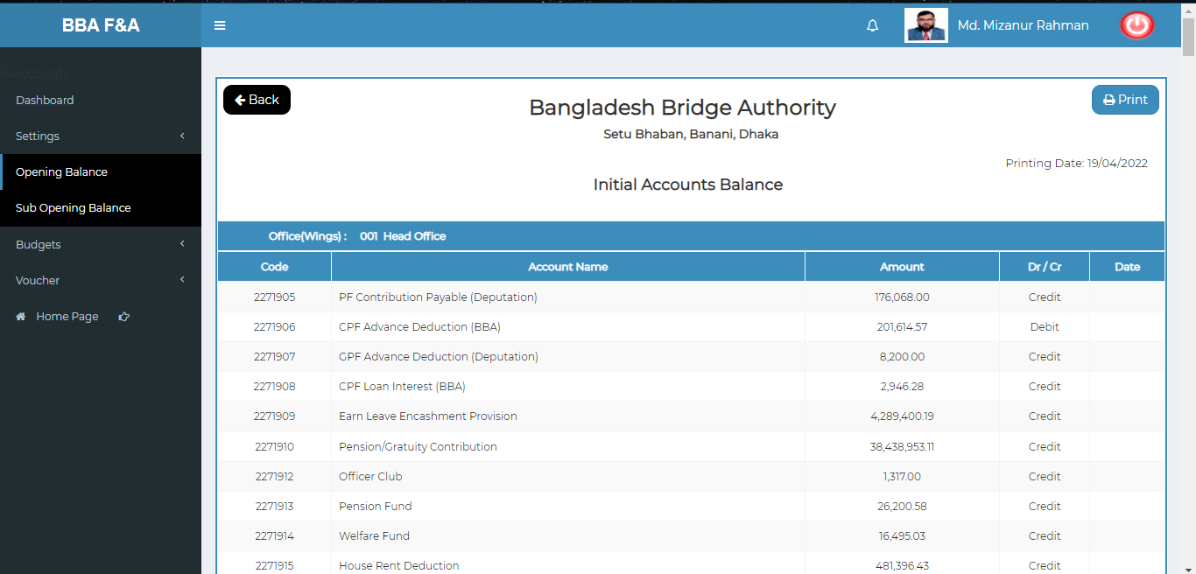

Figure 4.2.6.2: (Opening balance) Report (redirect to report page)

### 4.2.7: (Opening Balance) Print

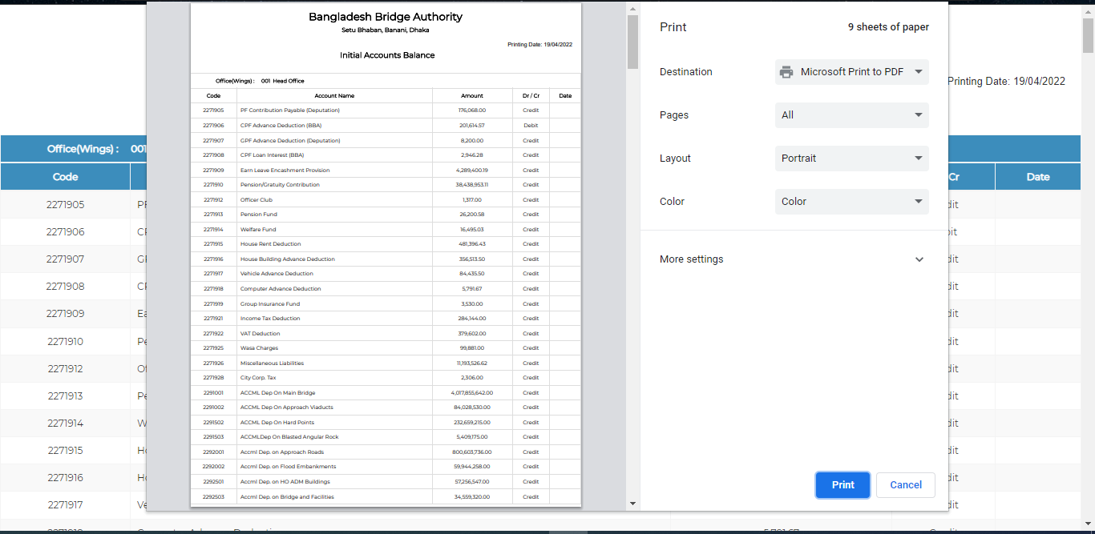

Figure 4.2.6.7: (Opening balance) Report (print)

## 4.3: Sub Opening Balance Menu Overview

## 

### 4.3.1: (Sub Opening Balance) Add Opening Balance Input Field

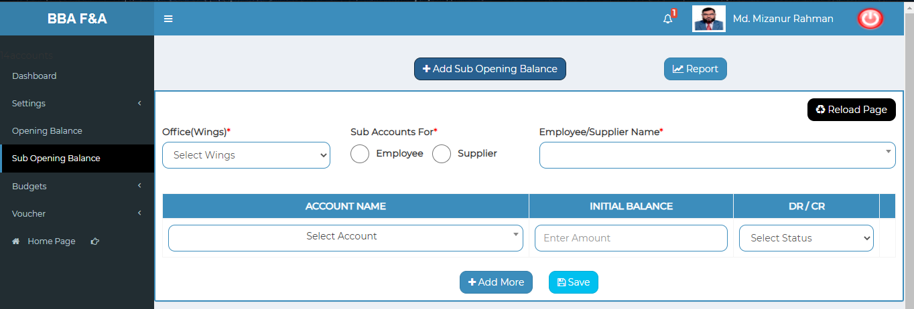

Figure 4.3.1: (Sub Opening balance) add Sub opening balance input field

### 4.3.2: (Sub Opening Balance) View of Sub Opening Balance

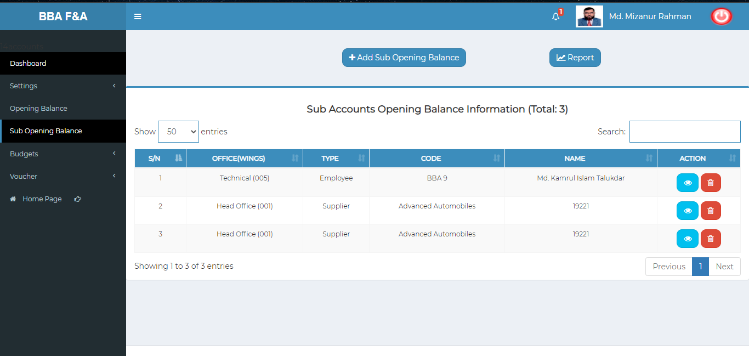

Figure 4.3.2: (Sub Opening balance) View of Sub opening balance

### 4.3.3: (Sub Opening Balance) View of Single Details

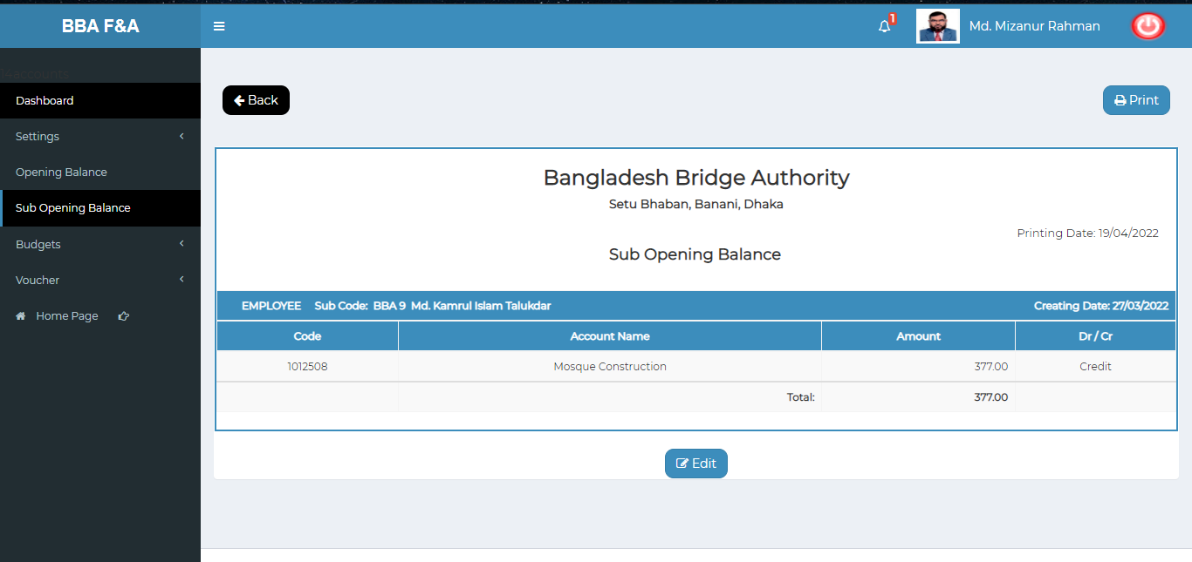

Figure 4.2.3: (Sub Opening balance) single details

### 4.3.3.1: (Sub Opening Balance) Single Details (Print)

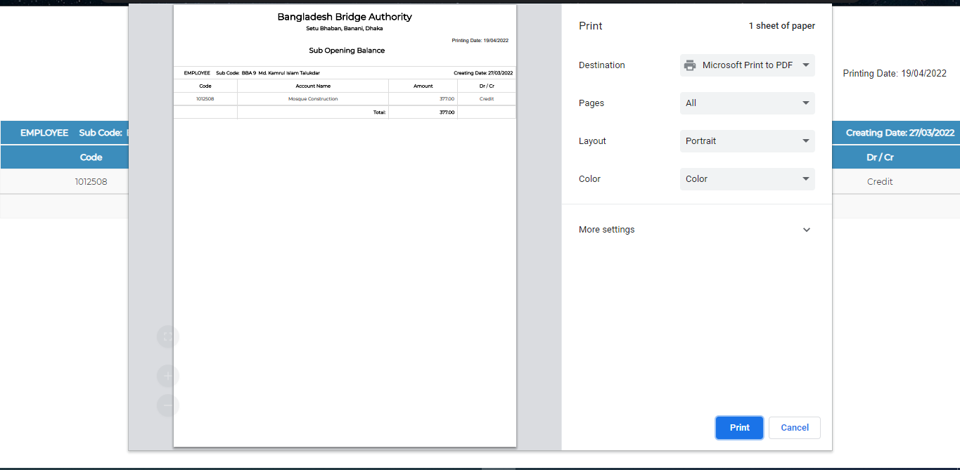 Figure 4.3.3.1: (Sub Opening balance) Single Details (Print)

### 4.3.3.2.1: (Sub Opening Balance) Single Details Edit (Sub Accounts For)

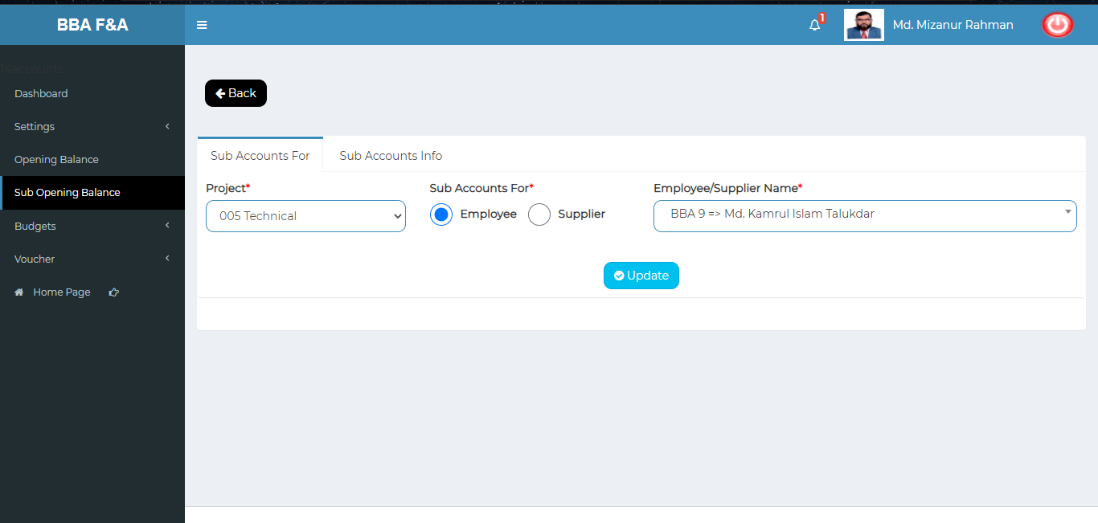

Figure 4.3.2: (Sub Opening balance) single details edit (sub accounts for)

### 4.3.3.2.2: (Sub Opening Balance) Single Details Edit (Sub Accounts Info)

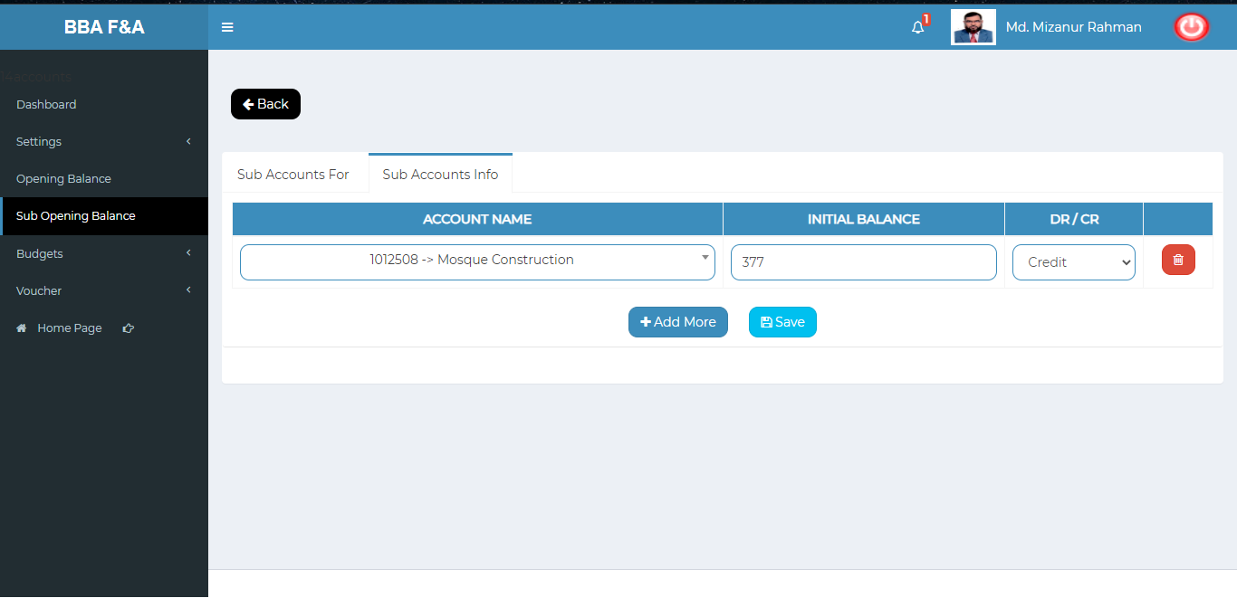

Figure 4.3.3.2.2: (Sub Opening balance) single details edit (sub accounts info)

### 4.3.4: (Sub Opening Balance) Delete

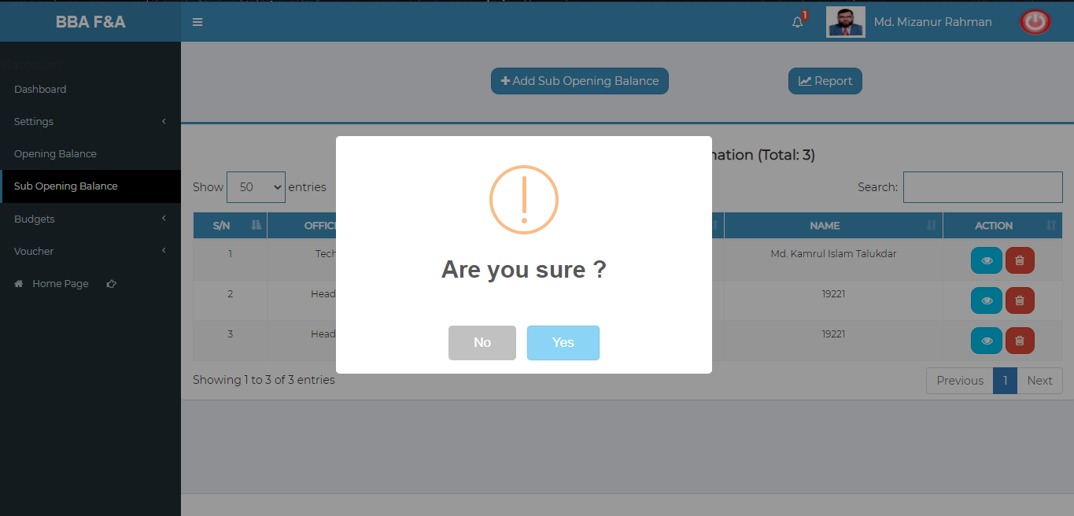

Figure 4.3.4: (Sub Opening balance) Delete

### 4.3.5: (Sub Opening Balance) Search

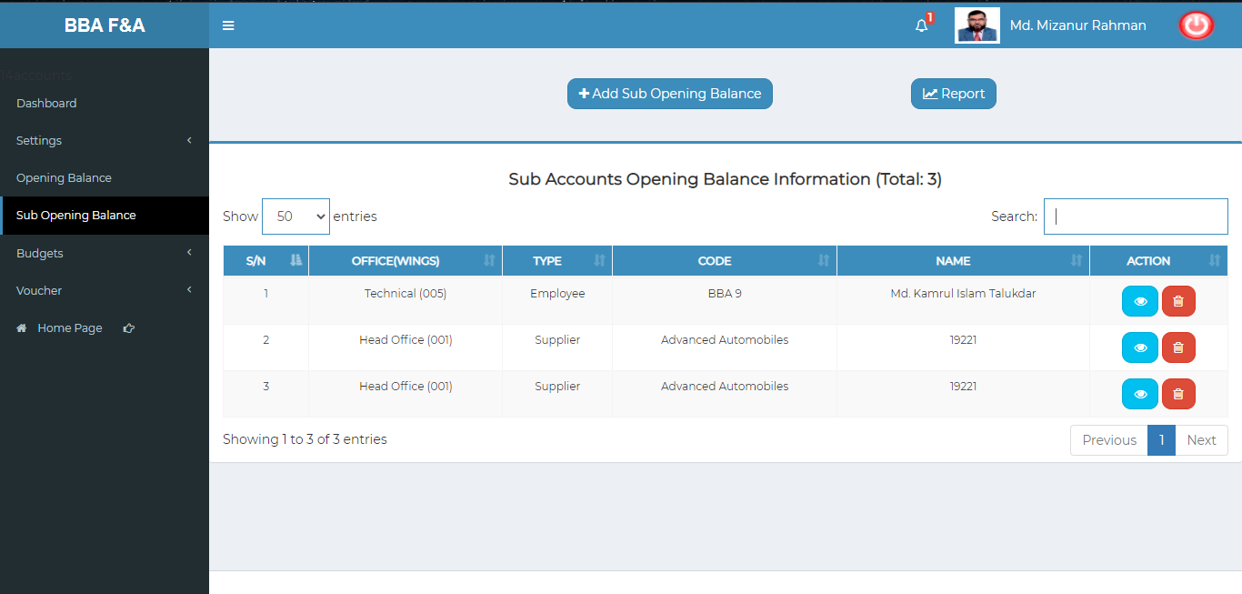

Figure 4.3.5: (sub Opening balance) before the search

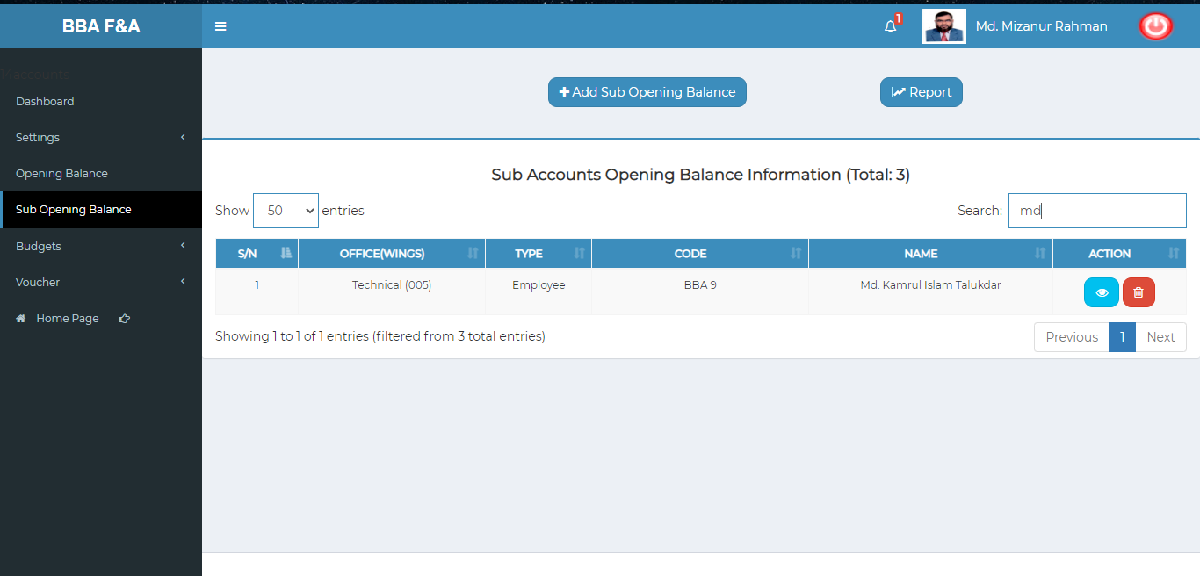

Figure 4.3.5.1: (Sub Opening balance) After search

### 4.3.6: (Sub Opening Balance) Report

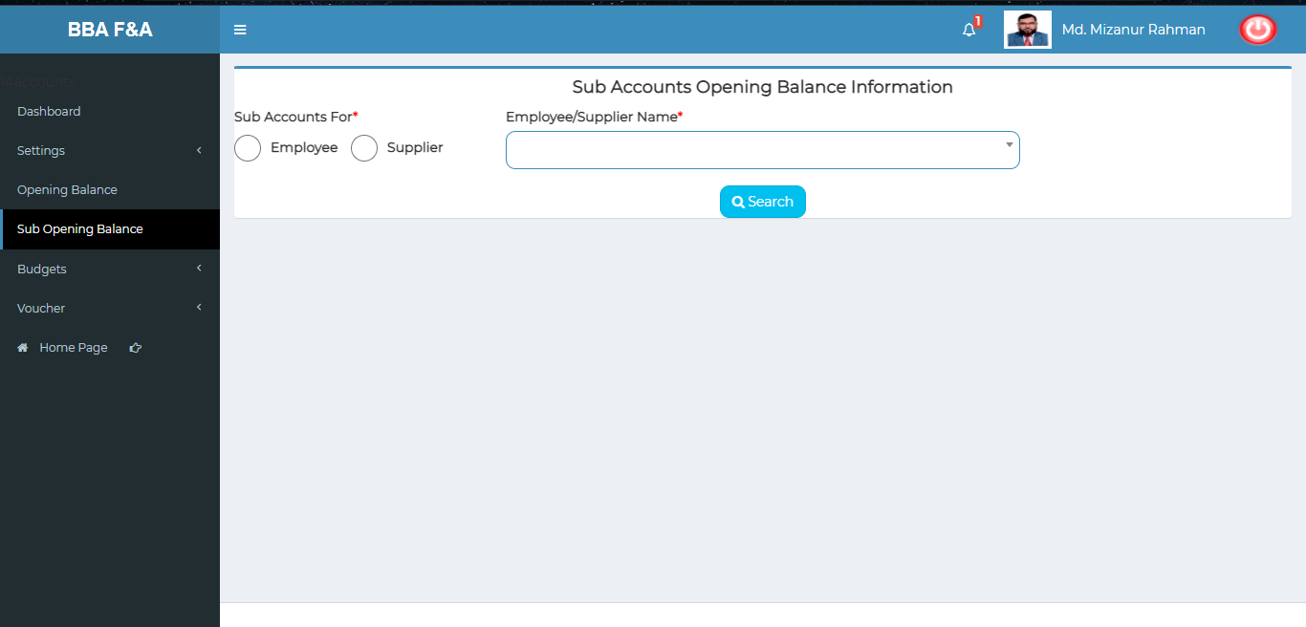

Figure 4.3.6: (Sub Opening balance) Report (input field to generate report)

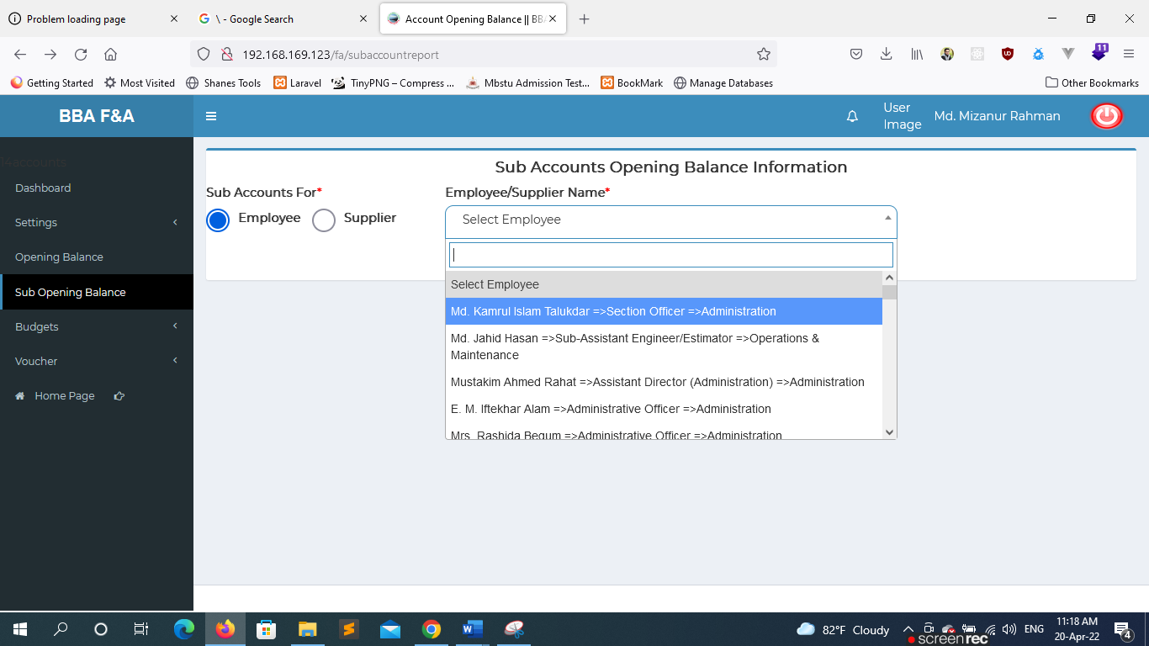

Figure 4.3.6.1: (sub Opening balance) Report (choose option from the input option field)

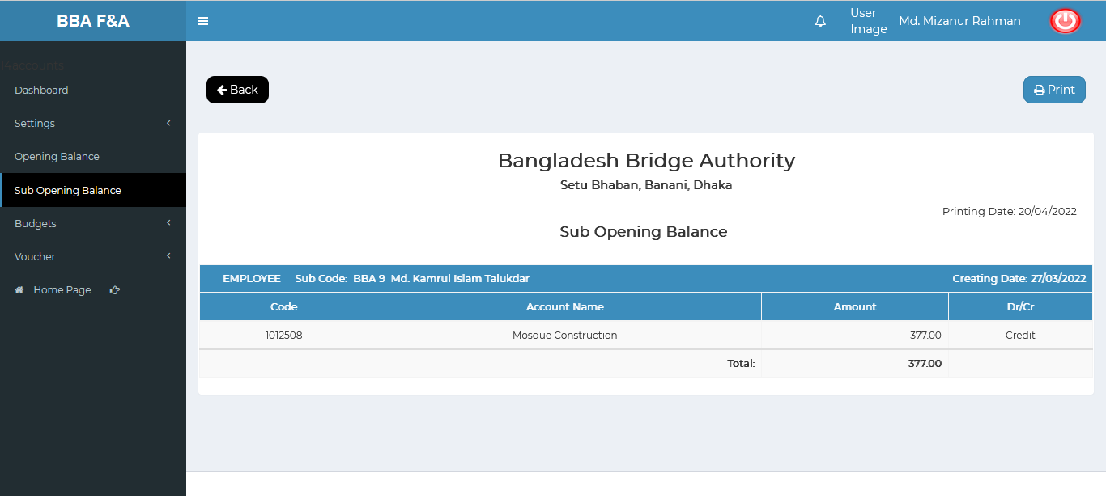

Figure 4.3.6.2: (Sub Opening balance) Report ( report page)

### 4.3.7: (Sub Opening Balance) Report Print

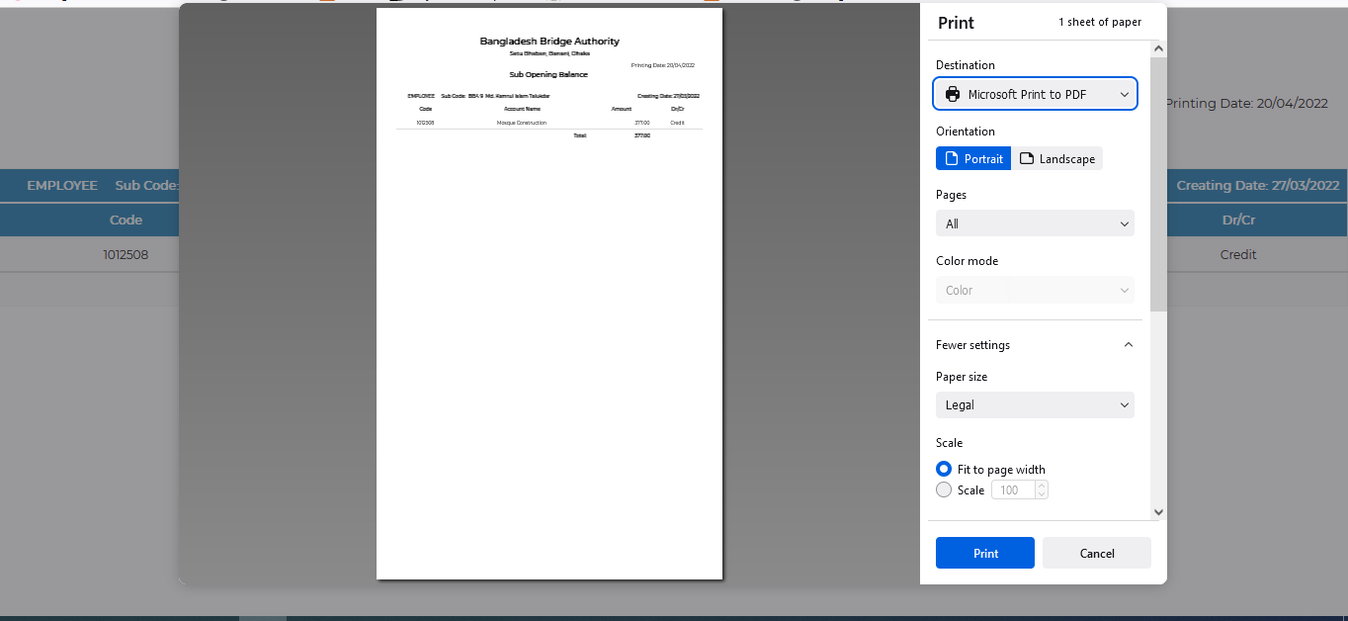

Figure 4.3.7: (Sub Opening balance) Report (print)

## 4.4: Budgets Menu Overview

**Overview of Budgets**

Click on the Budgets menu after that there will appear seven(07) sub-menu & they are **Budget Entry , Budget Manage ,Expenses Entry, Manage Expenses , Bills Entry, Manage Bills , Report .**

### 4.4.1.1: Budget Entry (Budgets) Budget Entry input field

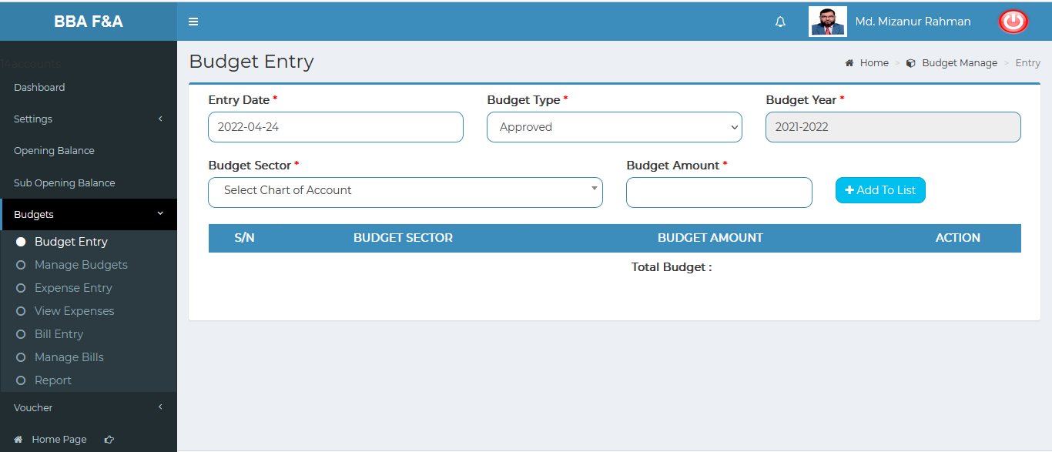

Figure 4.4.1.1: Budget entry(budgets) budget entry input field

### 4.4.1.2: Budget Entry (Budgets) View of Budget Entry Details

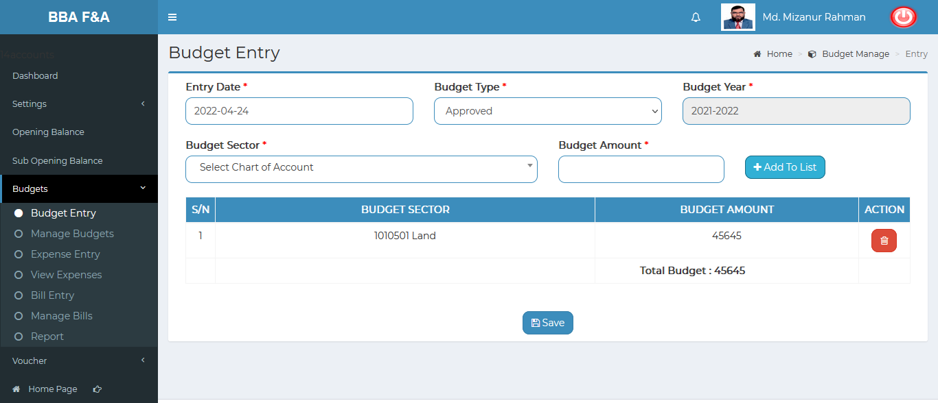

Figure 4.4.1.2: Budget entry(budgets) view of budget entry details

### 4.4.2.1: Manage Budget (Budgets) View all budget info (Year Wage)

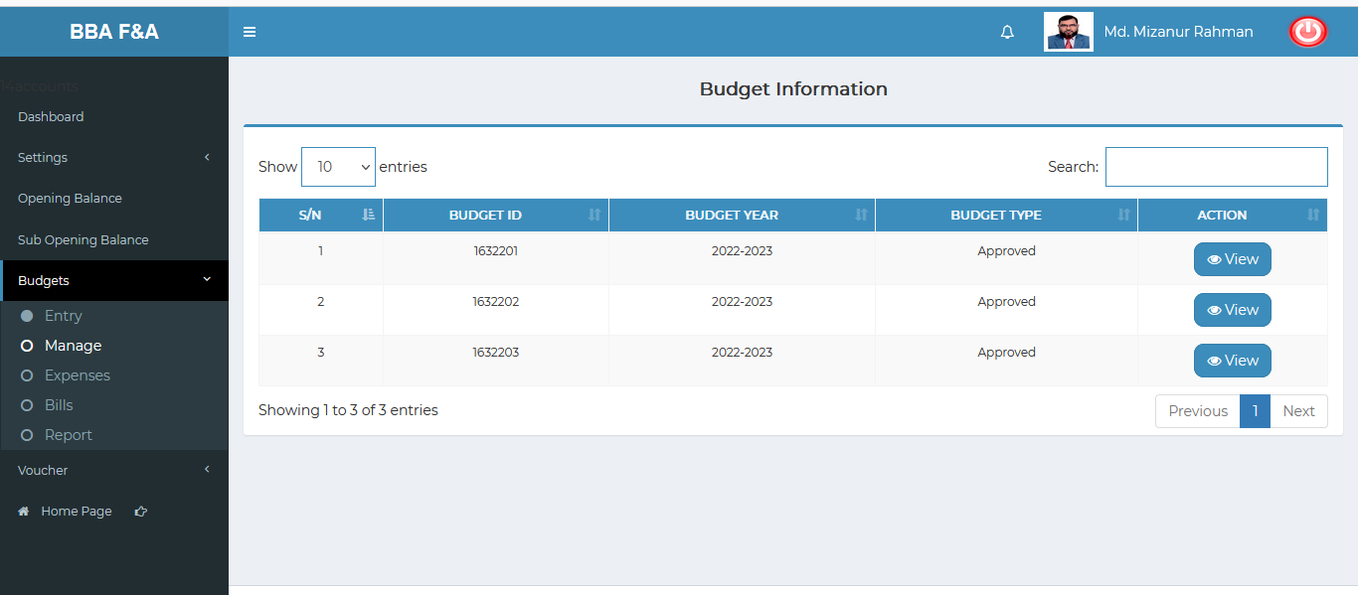

Figure 4.4.2.1: manage budget (budgets) view of all budget info (year wage)

### 4.4.2.2: Manage Budget (Budgets) View of single budget info

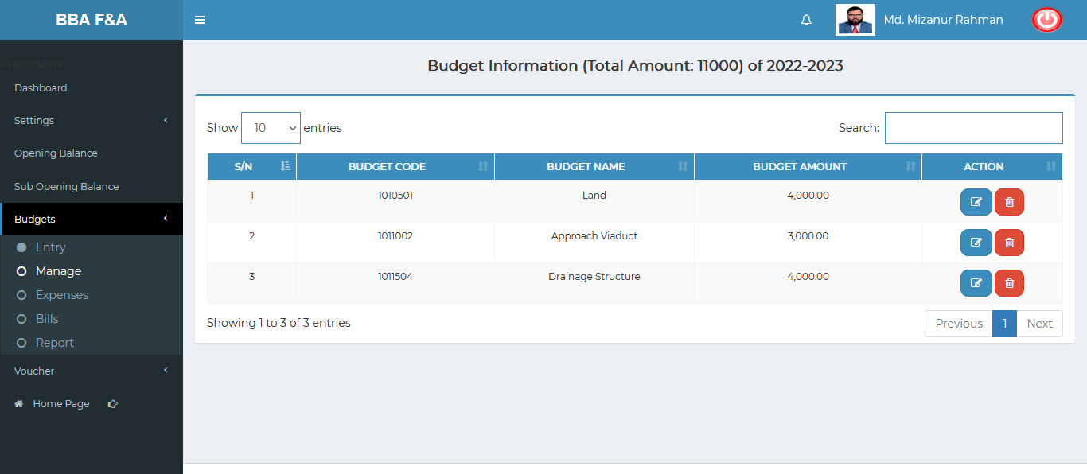

Figure 4.4.2.2: manage budget (budgets) view of single budget info

### 4.4.2.2.1: Manage Budget (Budgets) View of single budget info (Edit)

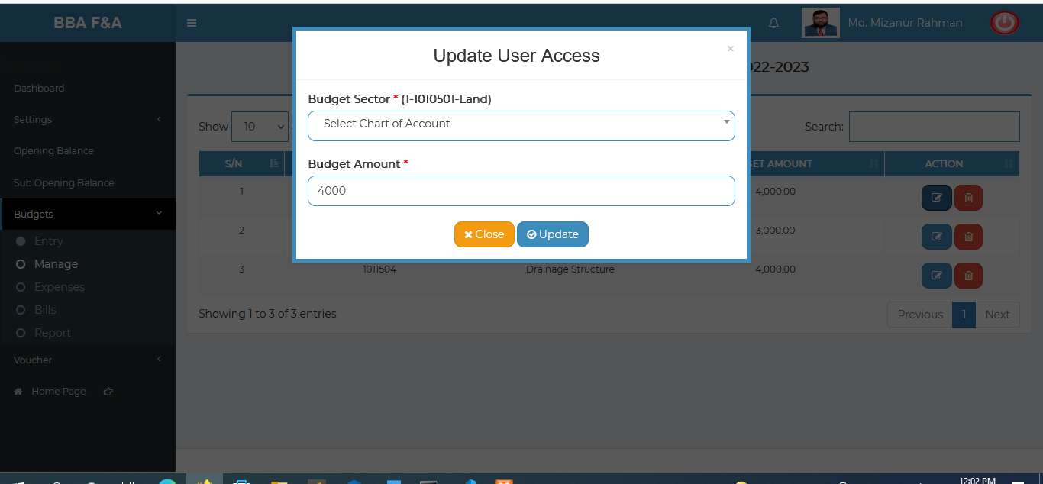

Figure 4.4.2.2.1: manage (budgets) view of single budget info (edit)

### 4.4.2.2.2: Manage Budget (Budgets) View of single budget info (Delete)

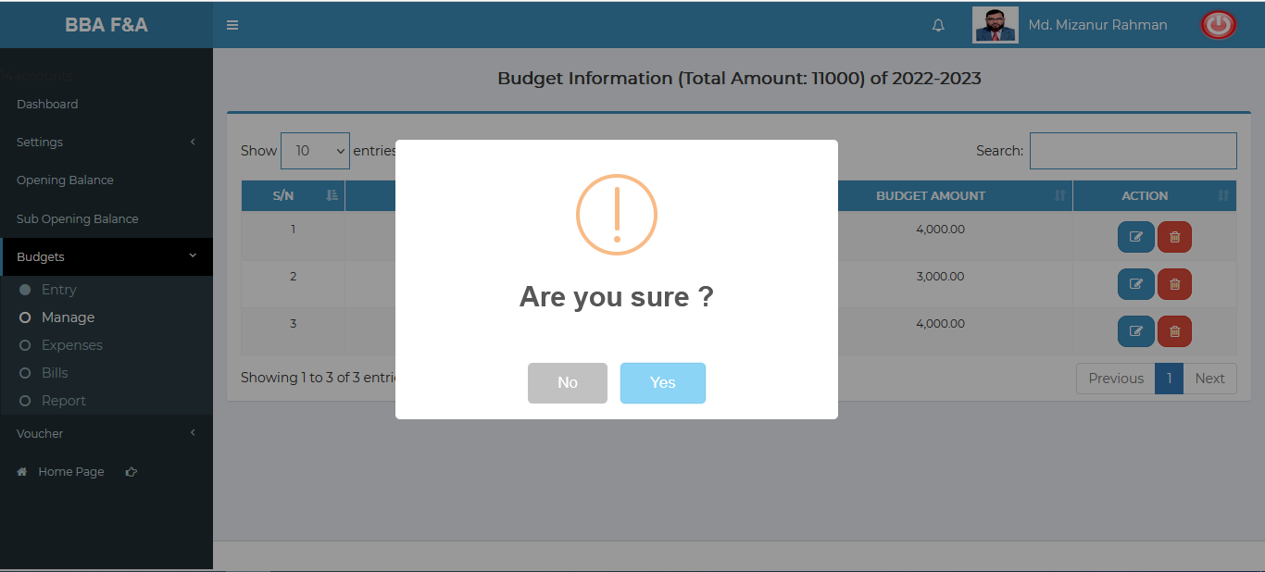

Figure 4.4.2.2.2: manage budget (budgets) view of single budget info (delete)

### 4.4.2.3: Manage Budget (Budgets) Search

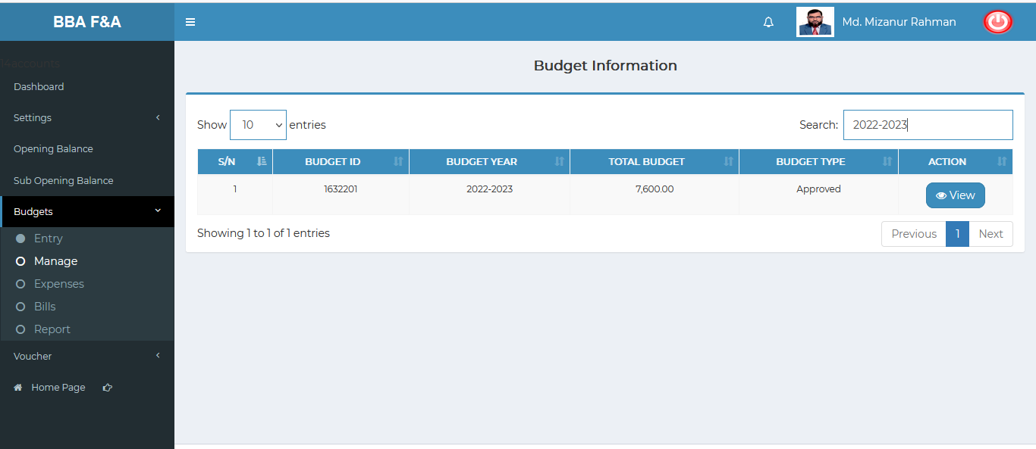

Figure 4.4.2.2.2: manage budget (budgets) search

### 4.4.3.1: Expense Entry (Budgets) Expense Entry input field

### 4.4.3.2: Manage Expenses (Budgets) (incomplete ….)

### 4.4.4.1: Bill Entry (Budgets) (incomplete ….)

### 4.4.4.2: Manage Bill (Budgets) (incomplete ….)

### 4.4.5: Report (Budgets) (incomplete ….)

## 4.5: Voucher Menu Overview

**Overview of Voucher**

Click on the Voucher menu after that there will appear four (04) sub-menu & they are **Entry , Manage , Report ,Old Records.**

### 4.5.1.1: Entry (Voucher) Voucher input form

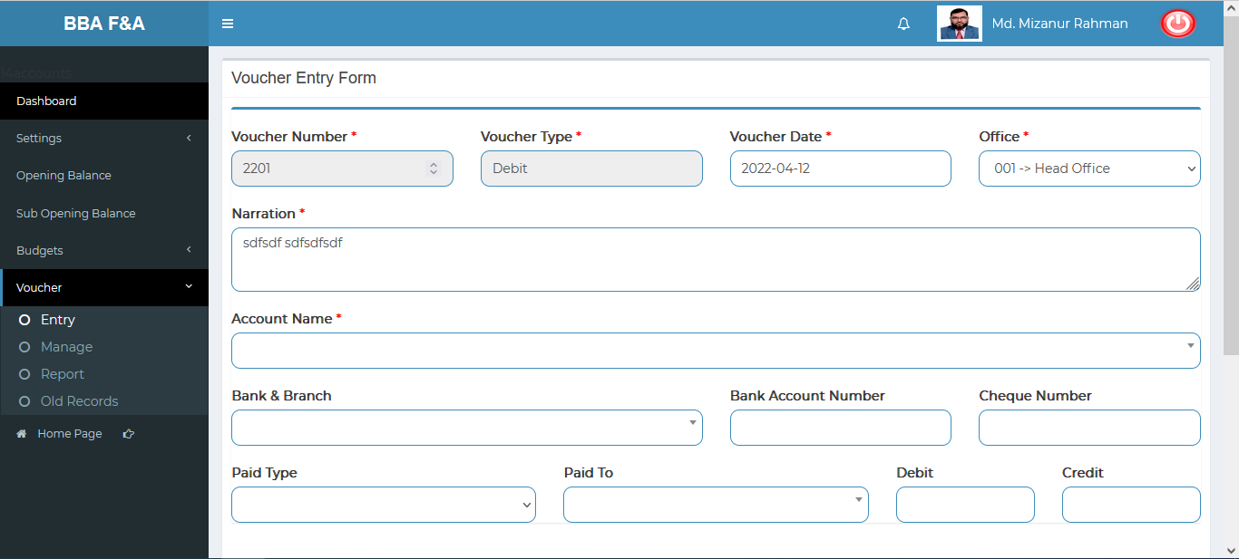

Figure 4.5.1.1: entry (Voucher) voucher input form

### 4.5.1.2: Entry (Voucher) View of Voucher Entry Details

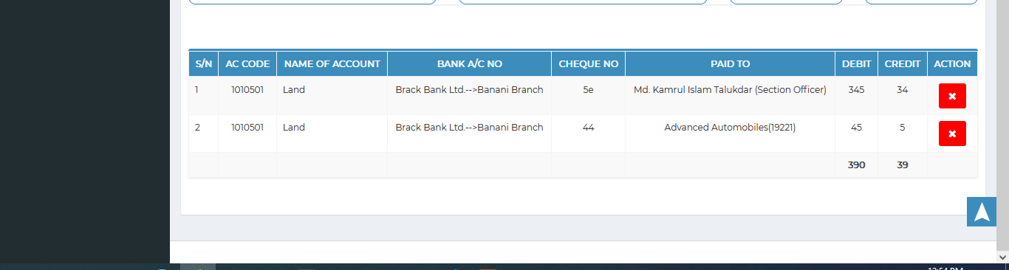

Figure 4.5.1.2: entry (Voucher) view of voucher entry details

### 4.5.2.1: Manage (Voucher) View Details of Voucher Information

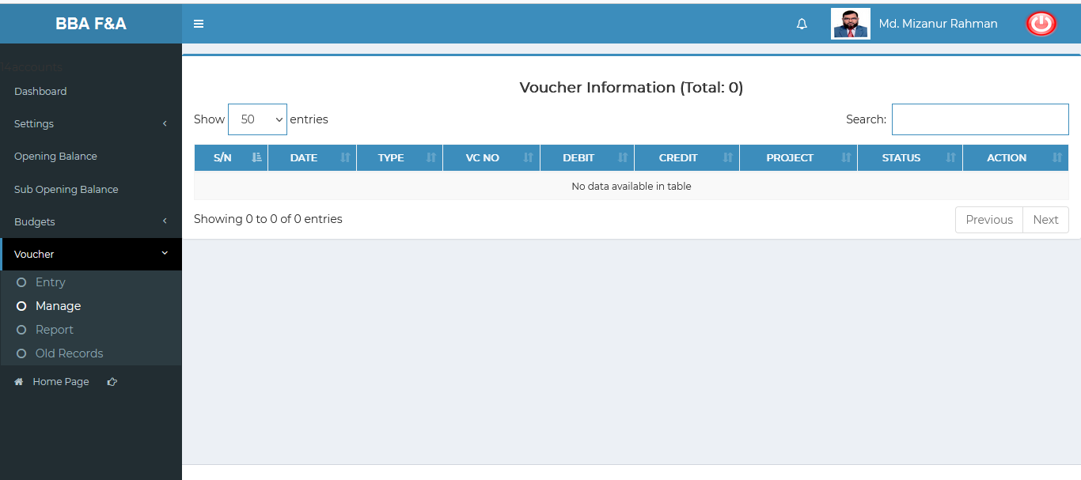

Figure 4.5.2.1: manage (Voucher) view of details voucher information

### 4.5.3.1: Report (Voucher) Report generator input field

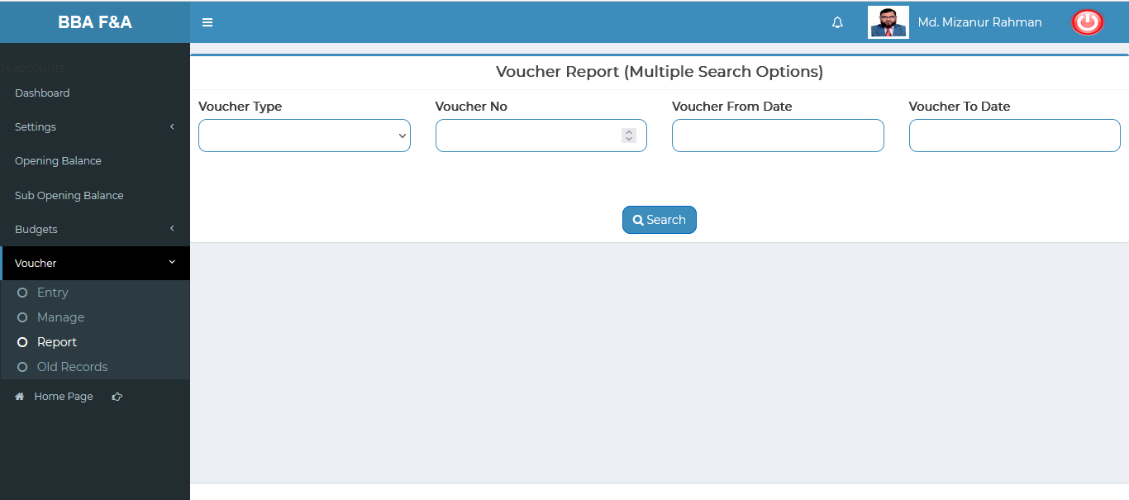

Figure 4.5.3.1: report (Voucher) report generator input field

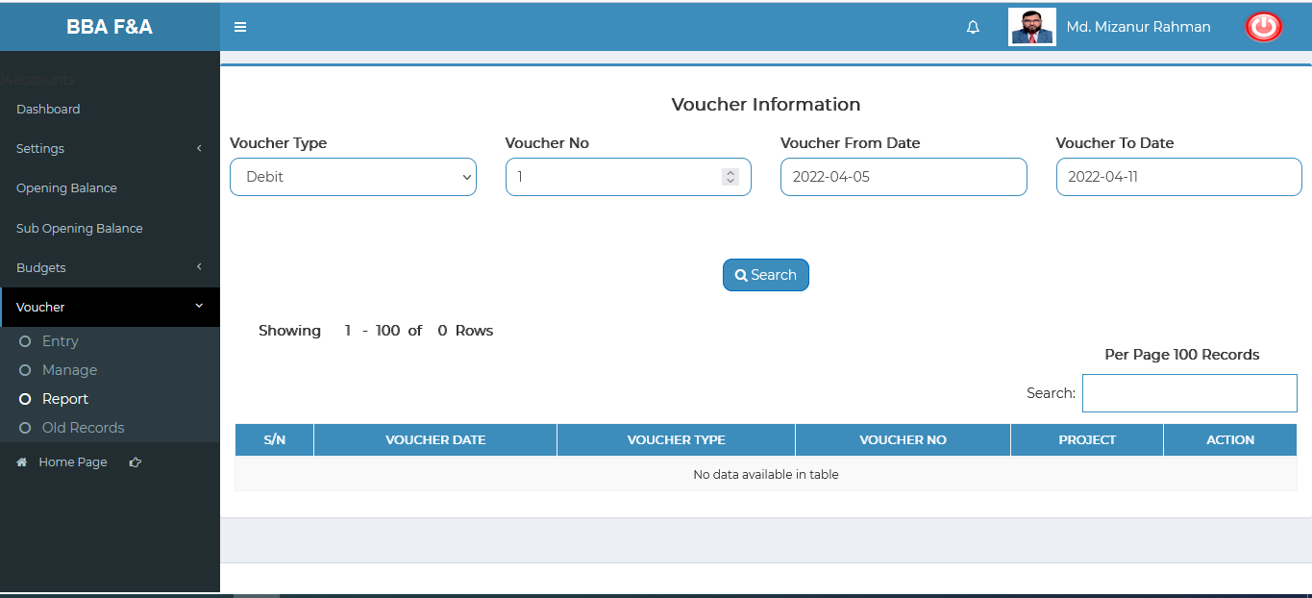

Figure 4.5.3.2: report (Voucher) voucher report

### 4.5.4.1: Old Records (Voucher) Search old record input field & Search result(Old Voucher info)

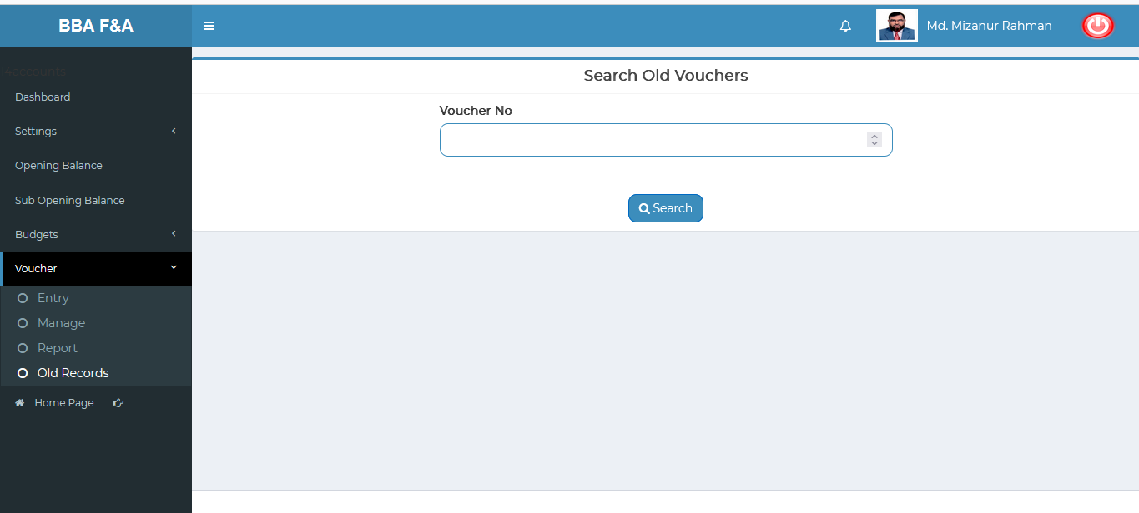

Figure 4.5.4.1: old records (Voucher) search old record input field

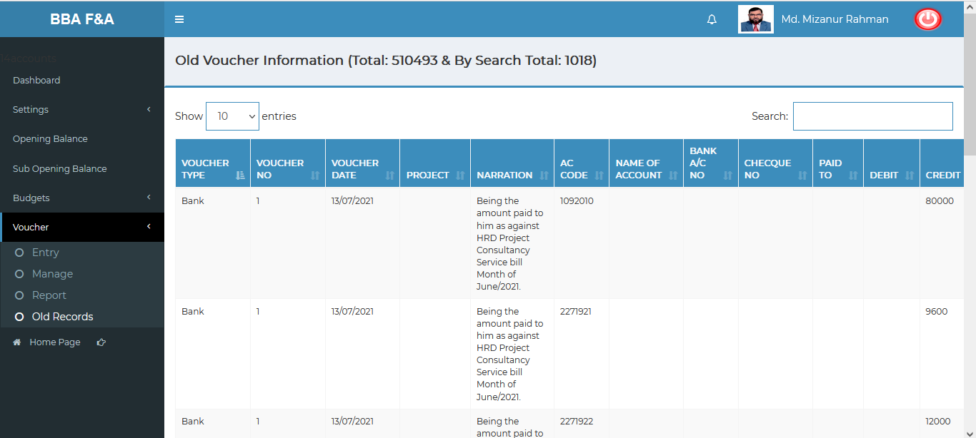

Figure 4.5.4.2: old records (Voucher) old records